Technical guidelines on the environmentally sound management of wastes consisting of, containing or contaminated with perfluorooctane sulfonic acid, its salts and perfluorooctane sulfonyl fluoride and perfluorooctanoic acid (PFOA), its salts and PFOA-related compounds

(Draft for review –Status: 2020-03-27

Contents
Abbreviations and acronyms 4
Units of measurement 4
I. Introduction 5
A. Scope 5
B. Description, production, use and wastes 5
1. Description 5
(a) PFOS, its salts and PFOSF 6
(b) PFOA, its salts and PFOA-related compounds 8
2. Production 8
(a) PFOS, its salts and PFOSF 9
(b) PFOA, its salts and PFOA-related compounds 9
3. Use 9
(a) PFOS, its salts and PFOSF 9
(b) PFOA, its salts and PFOA-related compounds 11
(b) PFOS and PFOA in products and articles 12
4. Wastes 12
II. Relevant provisions of the Basel and Stockholm conventions 13
A. Basel Convention 13
B. Stockholm Convention 15
(a) PFOS, its salts and PFOSF 15
(b) PFOA, its salts and PFOA-related compounds 17
III. Issues under the Stockholm Convention to be addressed cooperatively with the Basel Convention 19
A. Low POP content 19
B. Levels of destruction and irreversible transformation 19
C. Methods that constitute environmentally sound disposal 19
IV. Guidance on environmentally sound management (ESM) 19
A. General considerations 19
B. Legislative and regulatory framework 19
C. Waste prevention and minimization 20
D. Identification of wastes 20
1. Identification 21
2. Inventories 21
E. Sampling, analysis and monitoring 22
1. Sampling 22
2. Analysis 23
F. Handling, collection, packaging, labelling, transportation and storage 23
1. Liquids and semi-liquids (i.e., wastewater, landfill leachate, sewage sludge, hydraulic fluids and aqueous film-forming foams) 24
2. Solids (i.e., household and consumer textiles) 24
G. Environmentally sound disposal 24
1. Pre-treatment 24
2. Destruction and irreversible transformation methods 25
3. Other disposal methods when neither destruction nor irreversible transformation is the environmentally preferable option 25
4. Other disposal methods when the POP content is low 25
H. Remediation of contaminated sites 25
I. Health and safety 25
1. Higher-risk situations 25
2. Lower-risk situations 25
J. Emergency response 25
K. Public participation 25
Annex I to the technical guidelines 26
Annex II – Structural formulae of selected PFAS 29

Abbreviations and acronyms
CAS Chemical Abstracts Service
ECF electrochemical fluorination
EPA Environmental Protection Agency (United States of America)
ESM environmentally sound management
FEP polyfluoroethylene propylene
FOSA n-alkyl perfluorooctanesulfonamide
FOSE n-alkyl perfluorooctanesulfonamido ethanol
HDPE high-density polyethylene
ISO International Organization for Standardization
OECD Organisation for Economic Co-operation and Development
OEWG Open-ended Working Group (of the Basel Convention)
PFAS per-/polyfluorinated alkyl substances
PFBS perfluorobutane sulfonate

PFOA perfluorooctanoic acid
PFOS perfluorooctane sulfonic acid
PFOSA perfluorooctane sulfonamide
PFOSF perfluorooctane sulfonyl fluoride
POP persistent organic pollutant
PTFE polytetrafluoroethylene
PVDF polyvinylidene fluoride
UNEP United Nations Environment Programme
UNIDO United Nations Industrial Development Organization

Units of measurement
Mg  mg | megagram (1,000 kg or 1 tonne)  milligram (10⁻³ gram)
mg/kg | milligram(s) per kilogram. Corresponds to parts per million (ppm) by mass.

I. Introduction

A. Scope
- This document supersedes the Technical guidelines on the environmentally sound management of wastes consisting of, containing or contaminated with perfluorooctane sulfonic acid, its salts and perfluorooctane sulfonyl fluoride of May 2015.
- The present technical guidelines provide guidance on the environmentally sound management (ESM) of wastes consisting of, containing or contaminated with perfluorooctane sulfonic acid (PFOS), its salts and perfluorooctane sulfonyl fluoride (PFOSF) and perfluorooctanoic acid (PFOA), its salts and PFOA-related compounds pursuant to several decisions of two multilateral environmental agreements on chemicals and wastes.
- PFOS, its salts and PFOSF were listed in Annex B to the Stockholm Convention in 2009, through amendments that entered into force in 2010 and in 2020 .
- Along with PFOS, its salts and PFOSF, the present technical guidelines address other PFOS-related substances that are precursors of PFOS. In the guidelines, the term “PFOS-related substances” (also known as precursors) refers to substances that contain the PFOS carbon chain and moiety (defined as C₈F₁₇SO₂ or C₈F₁₇SO₃⁻), that can degrade to PFOS in the environment, and that are or were produced with PFOSF as an intermediate chemical. These chemicals are covered by the PFOSF listing in the Stockholm Convention.
- PFOA, its salts and PFOA-related compounds were listed in Annex A to the Stockholm Convention in 2019 through an amendment that entered into force in 2020 .

- The present document should be used in conjunction with the General technical guidelines on the environmentally sound management of wastes consisting of, containing or contaminated with persistent organic pollutants (UNEP, 2019) (hereinafter referred to as “general technical guidelines”). The general technical guidelines are intended to serve as an umbrella guide for the ESM of wastes consisting of, containing or contaminated with persistent organic pollutants (POPs) and provide more detailed information on the nature and incidence of wastes consisting of, containing or contaminated with PFOS and PFOS-related substances or PFOA and PFOA-related substances for purposes of their identification and management.
- In addition, the use of PFOS in pesticides is addressed in more detail in the Technical guidelines on the environmentally sound management of wastes consisting of, containing or contaminated with the pesticides aldrin, alpha hexachlorocyclohexane, beta hexachlorocyclohexane, chlordane, chlordecone, dicofol, dieldrin, endrin, heptachlor, hexachlorobenzene, lindane, mirex, pentachlorobenzene, perfluorooctane sulfonic acid, technical endosulfan and its related isomers or toxaphene or with hexachlorobenzene as an industrial chemical (UNEP, XXXX).

B. Description, production, use and wastes

Description
- PFOS and PFOA belong to the family of perfluoroalkyl- and polyfluoroalkyl substances, which are abbreviated as “PFAS”. Chemically, PFOS and PFOA are organic acids, with PFOS being a sulfonic acid and PFOA a carboxylic acid. PFOS and PFOA in water or other environmental media and depending on the pH, is present either in its protonated form (and occur as an acid) or anionic form (and with a cation, form salts).
- For information on nomenclature, classification and identity of perfluoroalkyl- and polyfluoroalkyl substances (PFAS), a review article (Buck et al., 2011) or OECD documents (OECD, 2013), (OECD, 2018) should be consulted.
- The strength of the C-F bonds contributes to the extreme stability of perfluorinated alkyl substances (PFAS) and gives them their distinctive properties. Due to the strong electronegativity and small atomic size of fluorine, the perfluoroalkyl moiety (C_{n}F_{2n+1}⁻) imparts enhanced properties to molecules (e.g., stronger acidity, higher surface activity at very low concentrations, stability, and/or water- and oil-repellency) compared to other hydrocarbons.
- Both, PFOS and PFOA, as other PFAS, have been manufactured for (i) direct use in commercial products and (ii) use in industrial product streams.
- PFOS and PFOA are not known to occur naturally.

(a) PFOS, its salts and PFOSF
- Perfluorooctane sulfonic acid (F-(CF₂)₈-SO₃H) (CAS no: 1763-23-1, PFOS) is a fully fluorinated (perfluorinated) alkane sulfonic acid (PFSA).
- PFOS occurs as a linear (L-PFOS) or branched compound (br-PFOS) depending on the chemical synthesis process. L- and br-PFOS have the same molecular formula C₈HF₁₇SO_{3.}

- The basic structure of L-PFOS is shown in Figure 1 below
Figure 1: Structural formula of PFOS (linear)
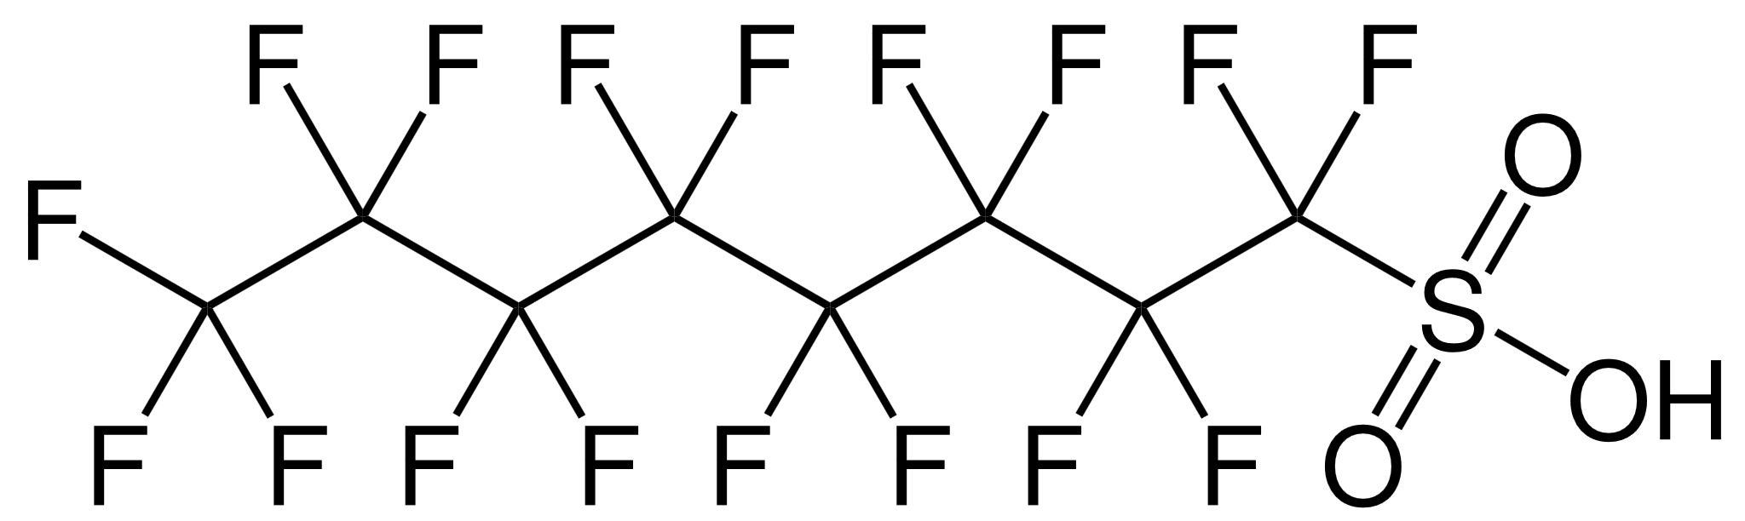
- PFOS has a molar mass of 500.13 g/mol and a boiling point of 133 °C (calculated 230 °C according to (Rayne and Forest, 2009)).
- When electrochemical fluorination is used, about 30% of the PFOS synthesized consists of branched isomers (br-PFOS). Two examples of branched isomers are shown Figure 2
Figure 2: Structural formula of br-PFOS
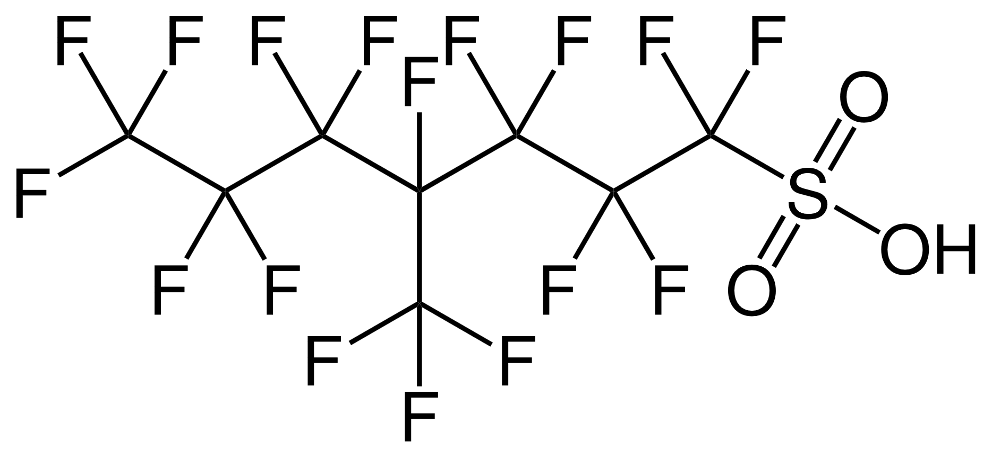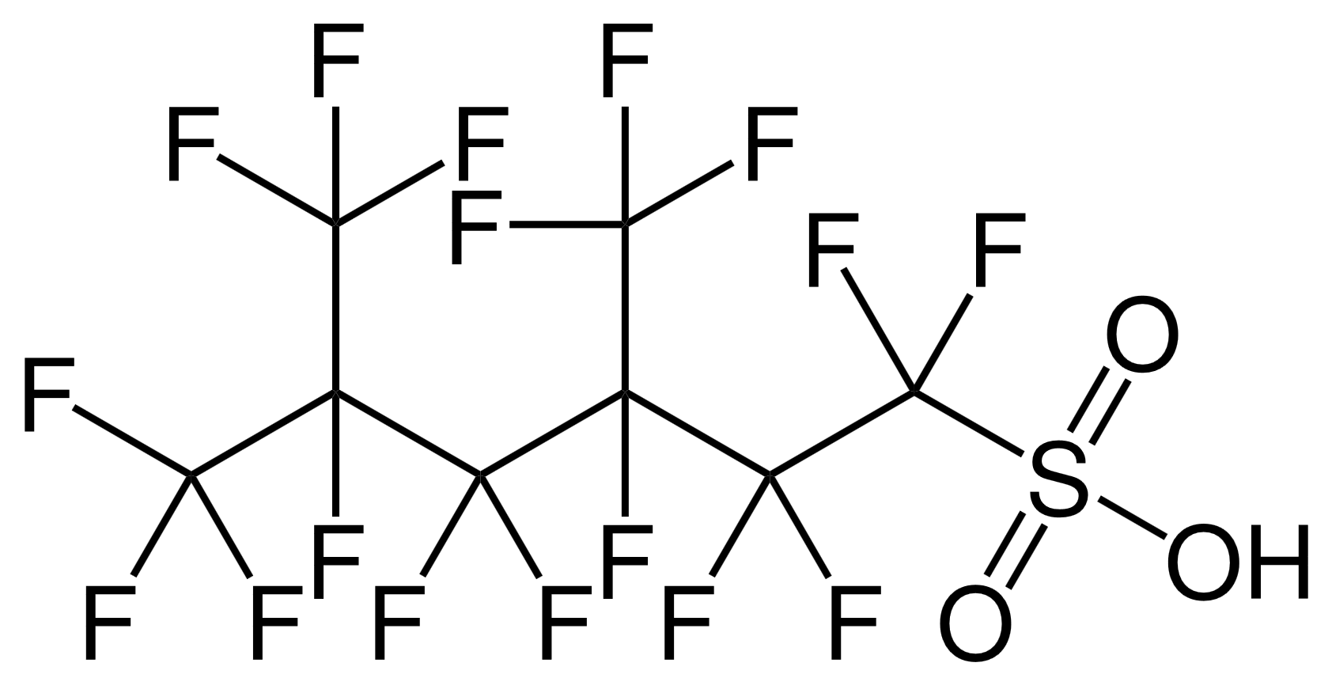
4-PFOS 3,5-PFOS
- PFOS is persistent and has bioaccumulative and biomagnifying properties, although it does not follow the classic pattern of other POPs by partitioning into fatty tissues; instead, it binds to proteins in blood and liver. It has the capacity to undergo long-range transport and has demonstrated ecotoxicity and toxicity towards mammals (UNEP/POPS/POPRC.2/17/Add.5).
- The International Agency for Research on Cancer (IARC) has not classified PFOS as to its carcinogenicity to humans (status: December 2019).

- PFOS anions most commonly exist as simple salts and include: potassium perfluorooctane sulfonate (CAS No. 2795-39-3); lithium perfluorooctane sulfonate (CAS No. 29457-72-5); ammonium perfluorooctane sulfonate (CAS No. 29081-56-9); diethanolammonium perfluorooctane sulfonate (CAS No. 70225-14-8); tetraethylammonium perfluorooctane sulfonate (CAS No. 56773-42-3); and didecyldimethyammonium perfluorooctane sulfonate (CAS No. 251099-16-8).
- The structural formula of the PFOS potassium salt is shown in Figure 3 below and corresponds to the molecular formula C₈F₁₇SO₃K.
Figure 3: Structural formula of the PFOS potassium salt
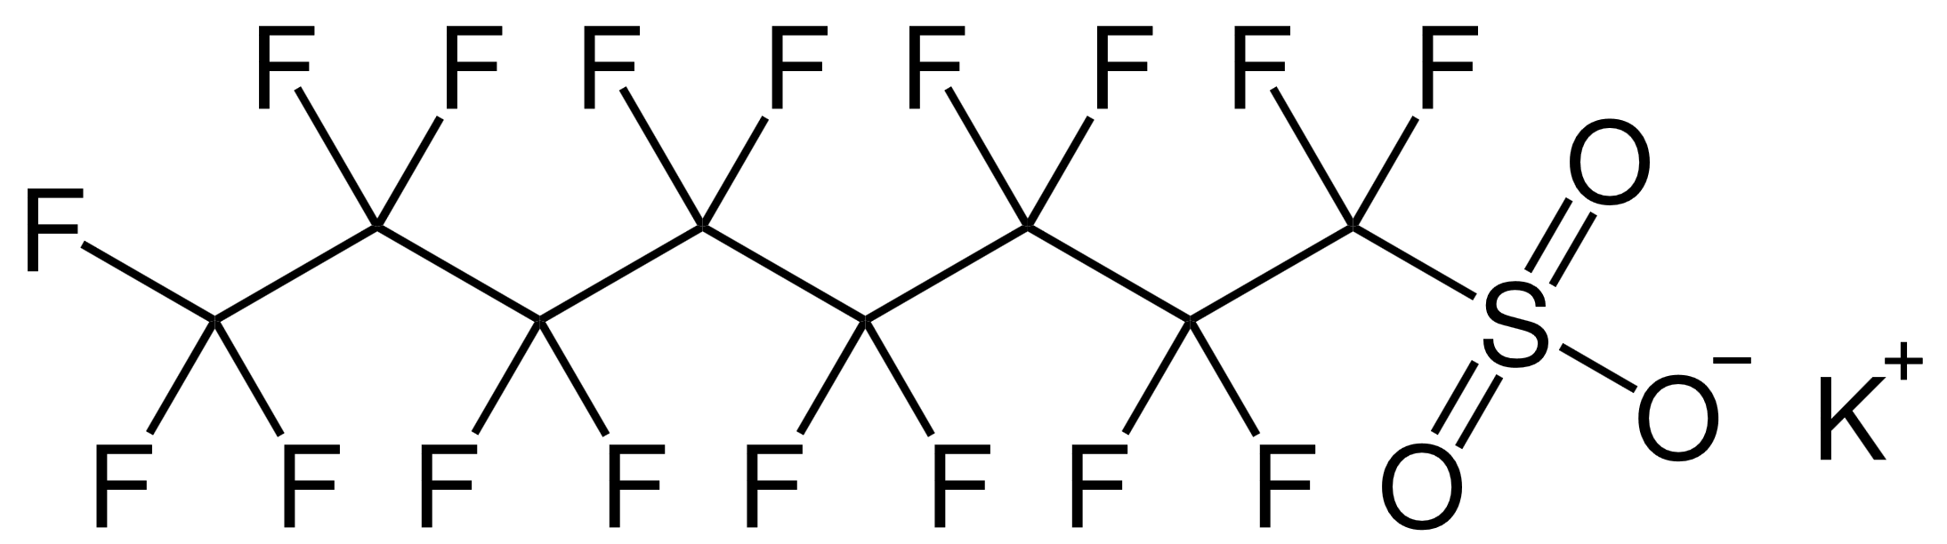
- PFOSF (CAS No. 307-35-7) is an intermediate to produce “PFOS-related substances” in the electrochemical fluorination process, i.e. all substances that contain one or more C₈F₁₇SO₂-groups and that can, or are assumed, to degrade to PFOS in the environment (UNEP/POPS/COP.7/INF/26). For example, to produce PFOS, N-alkyl perfluorooctanesulfonamides (FOSAs, F-(CF₂)₈-SO₂-NH(alkyl)) or N-alkyl perfluorooctanesulfon-amidoethanols (FOSEs, F-(CF₂)₈-SO₂-N(alkyl)(CH₂CH₂OH)). FOSA include EtFOSA which is used as a pesticide. FOSEs are key intermediates to produce other PFOS-related substances. For example, EtFOSE (N-ethyl perfluorooctanesulfonamidoethanol, F-(CF₂)₈-SO₂-N(C₂H₅)(CH₂CH₂OH))is the key intermediate to produce PFOS-related fluorinated polymers such as poly(meth)acrylates and polyurethanes (UNEP, 2017).
- The structural formula of PFOSF is shown in Figure 3 below and corresponds to the molecular formula C₈F₁₇SO₂F.
Figure 3: Structural formula of PFOSF
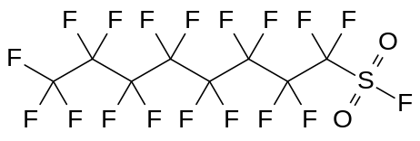
- PFOSF and its derivatives belong to the PASF (perfluoroalkanesulfonyl fluoride) subgroup (Buck et al., 2011).
- Direct precursors are neutral compounds that can transform into PFOS. For examples of these, see Table 1 in annex II.
- N-ethylperfluorooctanesulfon-amide (EtFOSA), also known as sulfluramid, is used as a pesticide to fight leaf-cutting ants (for further information, see POPs pesticides technical guidelines (UNEP, XXXX)). The structural formula of sulfluramid is shown in Figure 5.
Figure 5: Structural formula of EtFOSA (sulfluramid)
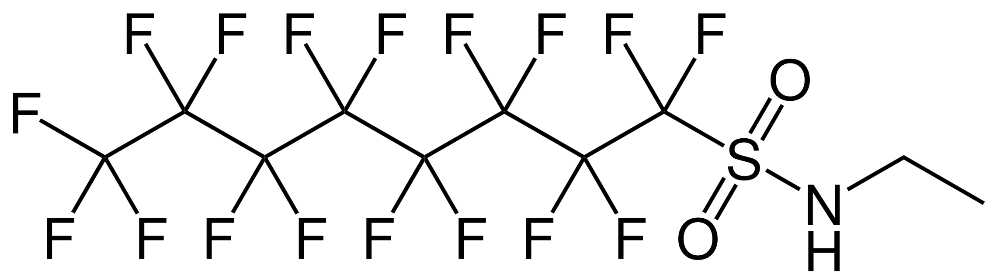

- The term "PFOS-related substances" does not show up in any of the two listings for PFOS; rather the listing refers to "PFOS, its salts and PFOSF” (for exact wording, see SC-4/17 and SC-9/4.) For the purpose of these technical guidelines, the term "PFOS-related substances" is used for all substances that contain one or more PFOS moiety (defined as C₈F₁₇SO₂). In the Stockholm Convention, these PFOS-related substances can be defined through the listing of PFOSF, an intermediate in the ECF process, and the listing of PFOS in the Convention. The PFOS moiety typically occurs as a salt or is incorporated into polymers. Analytically, these compounds are determined as an anion.
- Since PFOS-related substances are considered PFOS precursors, it is assumed that those substances have the same POP characteristics as PFOS.

- The majority of PFOS-related substances are polymers with high molecular weights of which PFOS is only a fraction (OECD, 2002). They have distinct properties different from non-polymeric PFAS and typically are classified as polymers-of-low-concern (PLC) ((Deloitte, 2015; Henry et al., 2018)). PFOS-related substances have been defined somewhat differently in different contexts and there are currently varying numbers of PFOS-related substances that are thought to have the potential to break down into PFOS.

(b) PFOA, its salts and PFOA-related compounds
- Perfluorooctanoic acid (PFOA; IUPAC name: pentadecafluorooctanoic acid, C₈HF₁₅O₂, CAS No: 335-67-1) is a fully fluorinated carboxylic acid (PFCA). The molecular structure is shown in Figure 6.
Figure 6: Structural formula of PFOA (linear)
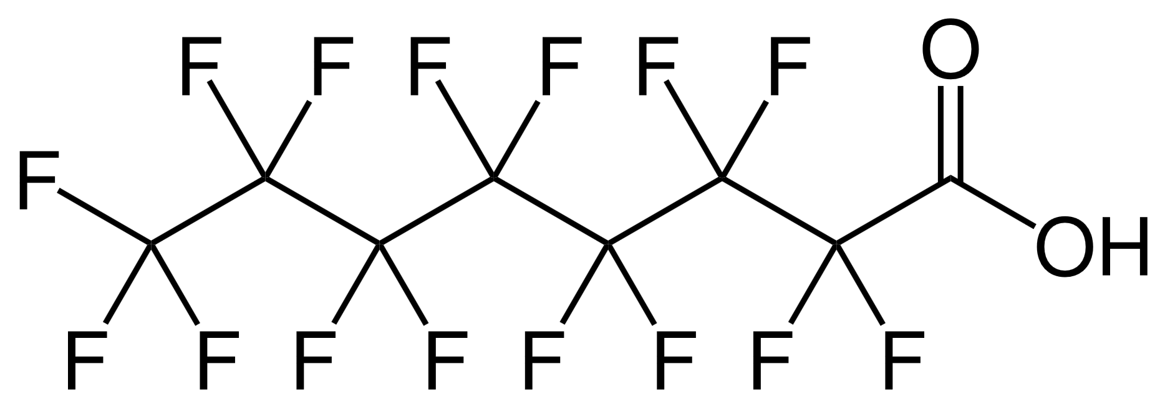

- There are 39 possible structural isomers of PFOA. PFOA can also occur as ammonium, sodium or potassium salts.
- PFOA is a white powder, having a boiling point of 192.4 °C and a melting point of 54.3 °C. Its water solubility is 9.5 g/L at 25 °C (IARC, 2018).
- The International Agency for Research on Cancer (IARC) classified PFOA as possibly carcinogenic to humans (Group 2B) (IARC, 2018).
- Under normal environmental conditions, PFOA is highly persistent, with photodegradation and hydrolysis half-lives of months to years, and insignificant biotic degradation (Environment Canada, 2012). It has low to moderate potential to accumulate in aquatic species, but does appear to accumulate in some terrestrial and marine mammals (Environment Canada, 2012).
- PFOA-related compounds, for the purposes of the Stockholm Convention, are any substances that degrade to PFOA, including any substances (including salts and polymers) having a linear or branched perfluoroheptyl group (C₇F₁₅) as one of the structural elements. Examples are:
  - Polymers with ≥C8 based perfluoroalkyl side chains;
  - 8:2 fluorotelomer compounds;
  - 10:2 fluorotelomer compounds.
- Explicitly excluded are compounds that do not degrade to PFOA:
  - C₈F₁₇-X, where X= F, Cl, Br;
  - Fluoropolymers that are covered by CF₃[CF₂]_{n}-R’, where R’=any group, n>16;
  - Perfluoroalkyl carboxylic and phosphonic acids (including their salts, esters, halides and anhydrides) with ≥8 perfluorinated carbons;
  - Perfluoroalkane sulfonic acids (including their salts, esters, halides and anhydrides) with ≥9 perfluorinated carbons;
  - Perfluorooctane sulfonic acid (PFOS), its salts and perfluorooctane sulfonyl fluoride (PFOSF), as listed in Annex B to the Stockholm Convention.”

Production

- PFOS and PFOA, like many other PFAS, are synthesized according to two pathways: (i) electrochemical fluorination (ECF) (since 1947) or (ii) telomerization.
  - Electrochemical fluorination (ECF) is a technology in which an organic raw material undergoes electrolysis in anhydrous HF, leading to the replacement of all the H atoms by F atoms. The free-radical nature of the process leads to C chain rearrangement and breakage, resulting in a mixture of linear and branched perfluorinated isomers and homologues. The ratio of linear to branched perfluorinated C chains is roughly 70% to 80% linear to 20% to 80% branched (in the case of PFOS).
  - Telomerization is a second important process for manufacturing perfluoroalkyl substances, in which a perfluoroalkyl iodide, C_{m}F_{2m+1}I (PFAI), most commonly pentafluoroethyl (or perfluoroethyl) iodide, C₂F₅I (PFEI), is reacted with tetrafluoroethylene, CF₂=CF₂ (TFE) to yield a mixture of perfluoroalkyl iodides with longer perfluorinated chains C_{m}F_{2m+1}(CF₂CF₂)_{n}I.
- PFAS are industrial chemicals that can be grouped into polymeric and non-polymeric substances.
- For information on production processes and numbers and uses of PFAS, see a review article (Prevedouros et al., 2006).

(a) PFOS, its salts and PFOSF
- The ECF of sulfonyl fluoride (C₈H₁₇SO₂F) yields:
    - Perfluorooctane sulfonyl fluoride (PFOSF, C₈F₁₇SO₂F), which is the major raw material used to manufacture PFOS (for structural formula, see Figure 3)
    - A series of functional raw materials such as sulfonamides, sulfonamido alcohols, and sulfonamido acrylate monomers, and
    - A family of surfactants and polymers derived therefrom
- Parties to the Stockholm Convention must restrict the production of PFOS, its salts and PFOSF, unless they have notified the Secretariat of their intention to produce those substances for an acceptable purpose or a specific exemption in accordance with part I of Annex B to the Convention. Information on the production of PFOS, its salts and PFOSF can be found in the registers of acceptable purposes and specific exemptions of the Stockholm Convention on the Convention website (www.pops.int). Information on the status of ratification by the parties of the amendment listing PFOS, its salts and PFOSF in the Stockholm Convention can be found on the website of the Treaty Section of the United Nations (https://treaties.un.org/).
- PFOS, its salts and PFOSF are still being produced for acceptable purposes and exemptions listed in part I of Annex B to the Stockholm Convention, such as insect baits, fire-fighting foams, and metal plating.

(b) PFOA, its salts and PFOA-related compounds
- PFOA, like PFOS, can be produced in the ECF from octanoyl fluoride (C₇H₁₅COF) to yield perfluorooctanoyl fluoride (C₇F₁₅COF), which is further reacted to make PFOA and its salts
- PFOA, its salts and PFOA-related compounds can still be produced as allowed for the Parties listed in the Register in accordance with the provisions of part X of Annex A (UNEP, 2019b).
- The actual production of PFOS and PFOA and their related substances cannot be quantified and confirmed due to a lack of reporting of production in many countries. Reference is made to the national reports under Article 15 of the Stockholm Convention. For environmental occurrence, information generated under the Global Monitoring Plan of the Stockholm Convention should be consulted.
- .

Use

- PFASs, both polymeric and non-polymeric, have been extensively used in various industries world-wide (see Table 1 and 2), due to their properties such as dielectrical properties, resistance to heat and chemical agents (acids, alkaline), low surface energy and low friction properties (UNEP, 2017). The highly stable carbon-fluorine bond and the unique physicochemical properties of PFASs make these substances valuable ingredients for products with high versatility, strength, resilience and durability, which provide benefits to manufacturers and consumers.

(a) PFOS, its salts and PFOSF
- Historically, PFOS has been used for a variety of products due to its surface-active properties, surface resistance/repellency to oil, water, grease or soil. PFOS has been used in electric and electronic parts, fire fighting foam, photo imaging, hydraulic fluids, leather, paper and textiles.
- With the exception of three uses, all of the uses above are not allowed for Parties to the Stockholm Convention that have accepted the listing according to S-9/4 (see the following paragraphs 50 to 52). Table 1 provides an overview of former uses according to PFOS or PFOS salt as well as an estimate of amounts present,
- There was never a direct use for PFOSF since it is an intermediate in only one process (see paragraph 38).

- Parties to the Stockholm Convention must eliminate the use of PFOS, its salts and PFOSF unless they have notified the Secretariat of their intention to use them for the one acceptable purpose or in accordance with the two specific exemption listed in part I of Annex B to the Convention. Information on the current use of PFOS, its salts and PFOSF can be found in the registers of acceptable purposes and specific exemptions of the Stockholm Convention on the Convention website (www.pops.int). Information on the status of ratification by the parties of the amendment listing PFOS, its salts and PFOSF in the Convention can be found on the website of the Treaty Section of the United Nations (https://treaties.un.org/) or the Stockholm Convention website (http://chm.pops.int/Countries/StatusofRatifications/Amendmentstoannexes/tabid/3486/Default.aspx).
- PFOS, its salts and PFOSF are still being used for one acceptable purposefor agricultural use only and exemptions listed in part I of Annex B to the Stockholm Convention, i.e., metal plating (hard-metal plating) but only in closed-loop systems and fire-fighting foam for liquid fuel vapour suppression and liquid fuel fires (Class B). Earlier specific exemptions expired with decision SC-9/4 .
- A PFOS precursor, N-ethylperfluorooctanesulfonamide (EtFOSA; ), can still be used for one acceptable purpose, namely insect baits with sulfluramid (CAS No: 4151-50-2) as an active ingredient for control of leaf-cutting ants from Atta spp. and Acromyrmex spp. (for further information, see POPs pesticides technical guidelines (UNEP, XXXX)).
- PFOS salts can still be used in hard metal plating. It is known that the tetraethylammonium (TEA, CAS No. 56773-42-3), potassium (K, CAS No. 2795-39-3), lithium (Li, CAS No. 29457-72-5), and diethanolamine (DEA, CAS No. 70225-14-8) salts are/have been used at concentrations between 0.03% and 0.08% (UNEP 2017 BAT/BEP guideline).
- PFOS can still be used in firefighting foams for liquid fuel vapour suppression and liquid fuel fires. Applications used to contain between 0.5% and 6% of PFOS.
- The use of PFOS or its salts is no longer allowed in the following uses (eliminated at COP-9) as shown in Table 1.
Table 1: Former uses of PFOS and its salts that are expired and updated in light of the SC-9/4 (adjusted from UNEP 2017 BAT/BEP guideline)
Use in former acceptable purposes | Incumbent PFOS or PFOS-related Substance | Typical Use Rate
Photo-imaging | FOSA quaternary ammonium salt (CAS No. 1652-63-7)  PFOS salt (TEA*(CAS No. 56773-42-3))  Polymeric mixtures (not further specified) | Inconsistent Information
Photoresist and anti-reflective coatings for semiconductors | Inconsistent Information | 0.02% to 0.1%  ~ 0.1%
Etching agent for compound semiconductors and ceramic filters | PFOS (CAS No. 1763-23-1) | Inconsistent Information
Aviation hydraulic fluids | Perfluoroethylcyclohexyl sulfonate (CAS No. 67584-42-3) | <0.05%
Certain medical devices (such as ethylene tetrafluoroethylene copolymer (ETFE) layers and radio opaque ETFE production, in-vitro diagnostic medical devices, and CCD colour filters) | PFOS (CAS No. 1763-23-1) | Inconsistent Information  150 ng for CCD Filter
Fire fighting foam | PFOS (CAS No. 1763-23-1) | 0.5% to 6%
Photo masks in the semiconductor and liquid crystal display (LCD) industries | PFOS (CAS No. 1763-23-1) | Inconsistent Information
Electric and electronic parts for some colour printers and colour copy machines | Inconsistent Information | Inconsistent Information
Chemically driven oil production | PFOS (CAS No. 1763-23-1) and non-specified PFOS-related substances | Inconsistent Information
Carpets | Acrylate or methacrylate or adipate or urethane copolymers with EtFOSE (N-ethyl perfluorooctane sulfonamide ethanol) as raw material | Up to 15% of weight of fiber
Leather and apparel | Acrylate or methacrylate or adipate or urethane copolymers with EtFOSE (N-ethyl perfluorooctane sulfonamide ethanol) as raw material  FOSA Amphoterics (not further specified) | Inconsistent Information
Textiles and upholstery | Acrylate or methacrylate or adipate or urethane copolymers with EtFOSE (N-ethyl perfluorooctane sulfonamide ethanol) as raw material | 2% to 3% of weight of fiber
Paper and packaging | Mono-, di- or triphosphate esters of N-ethyl perfluorooctane sulfonamide ethanol (EtFOSE)  N-Methyl perfluorooctane sulfonamide ethanol acrylate (co)polymers | 0.1% to 1.0% based on dry weight of paper
Coatings and coating additives | PFOS-salts: K (CAS No. 2795-39-3), Li (CAS No. 29457-72-5), DEA* (CAS No. 70225-14-8), NH₄ (CAS No. 29081-56-9)  potassium N-ethyl-N-[(heptadecafluoro-octyl) sulfonyl] glycinate (CAS No. 2991-51-7) | 0.01% to 0.05%
Rubber and plastics | PFOS (CAS No. 1763-23-1) | Inconsistent Information

(b) PFOA, its salts and PFOA-related compounds
- PFOA is a processing agent and serves as a surfactant in the emulsion polymerization of fluoropolymers and as a building block for the synthesis of perfluoroalkyl-substituted compounds, polymers, and polymeric materials. PFOA has been manufactured since the 1940s in industrial quantities. It is also formed by the degradation of precursors such as some fluorotelomers.
- Parties to the Stockholm Convention must eliminate the use of PFOA, its salts and PFOA-related compounds unless they have notified the Secretariat of their intention to use them in accordance with one of the nine specific exemption listed in part X of Annex A to the Stockholm Convention. Such specific exemptions include photolithography or etch processes in semiconductor manufacturing, photographic coatings applied to films, textiles for oil- and water-repellency for the protection of workers from dangerous liquids that comprise risks to their health and safety, invasive and implantable medical devices, fire-fighting foam for liquid fuel vapour suppression and liquid fuel fires (Class B fires) in installed systems, including both mobile and fixed systems, in accordance with paragraph 2 of part X of this Annex; Use of perfluorooctyl iodide for the production of perfluorooctyl bromide for the purpose of producing pharmaceutical products, in accordance with the provisions of paragraph 3 of part X of this Annex; Manufacture of polytetrafluoroethylene (PTFE) and polyvinylidene fluoride (PVDF); Manufacture of polyfluoroethylene propylene (FEP) for the production of high-voltage electrical wire and cables for power transmission; Manufacture of fluoroelastomers for the production of O-rings, v-belts and plastic accessories for car interiors .
- For use of PFOA, its salts and PFOA-related compounds, decision SC-9/9 contains the following restrictions:
  - “not use fire-fighting foam that contains or may contain PFOA, its salts and PFOA-related compounds for training;
  - Not use fire-fighting foam that contains or may contain PFOA, its salts and PFOA-related compounds for testing unless all releases are contained;
- Time-limited restrictions include
  - By the end of 2022, if it has the capacity to do so, but no later than 2025, restrict uses of fire-fighting foam that contains or may contain PFOA, its salts and PFOA-related compounds to sites where all releases can be contained;
  - Make determined efforts designed to lead to the environmentally sound management of fire-fighting foam stockpiles and wastes that contain or may contain PFOA, its salts and
  - PFOA-related compounds, in accordance with paragraph 1 of Article 6, as soon as possible;
- With regard to the specific exemption for the use of perfluorooctyl iodide for the production of perfluorooctyl bromide for the purpose of producing pharmaceutical products, at its thirteenth ordinary meeting and at every second ordinary meeting thereafter, the Conference of the Parties shall review the continued need for this specific exemption. This specific exemption shall in any case expire at the latest in 2036.

(b) PFOS and PFOA in products and articles
- The following paragraphs provide an initial orientation on more recent measurements for PFOS and PFOA in products or applications:
- PFOS was not found (at a detection limit of 0.01 mg/L) in 24 fire-fighting foams from European producers (purchased between 2014 and 2016). PFOA was quantified in 10 of 24 foams with concentrations between 0.003 mg/L and 0.34 mg/L (Dubocq et al. 2019).
- In a report by the Nordic Council of Ministers, textiles collected in 2014, did not contain quantifiable amounts of PFOS and two of the eight products contained PFOA in the range 1.7 µg/kg to 6.6 µg/kg.
- Twenty-nine samples of household products were analysed for PFAS PFOA was identified in the following products: Glider for skis 92.4 µg/kg and 53 µg/kg for PFOS, ski wax 0.97 µg/kg. lubricant for bicycles – 56.9 µg/kg, dental floss at 0.1 and 13.1 µg/kg

Wastes
- Action aimed at waste streams of importance in terms of volume and concentration will be essential to eliminating, reducing and controlling the environmental load of PFOS and PFOA from waste management activities. In that context, the following should be recognized:
- It is likely that PFOS and PFOA and their related substances are released into the environment throughout their life cycles (production, product assembly, consumer use, and disposal, including recycling);
- Waste management activities have been identified as one route through which PFOS and PFOA and their related substances can enter the environment, mainly through industrial and municipal wastewater discharges to surface waters and through leachate from landfills;
- Wastes may contain variable concentrations of PFOS and its related substances, depending on the quantities in which those substances were originally present in specific products and the quantities released during product use and end-of-life management;
- The primary media for the release of PFOS and PFOA and their related substances from waste management activities are likely to be water, sediments and soils;
- For wastes contaminated with PFOS and PFOA and their related substances, important considerations occur where high volumes of such wastes are found and a high potential for exposure is present, as in the case of contaminated sewage sludge.
- Wastes consisting of, containing or contaminated with PFOS and PFOA and their related substances may be found in a number of physical forms, including:
  - Solid obsolete stockpiles of PFOS and PFOA and their related substances in original packages which are no longer usable because their shelf life has been exceeded or the packaging has deteriorated;
  - Soil and sediments;
  - Solid waste (food packaging materials, paper, textiles, leather, rubber and carpets);
  - Production wastes from fluorinated chemicals;
  - Fire suppression equipment;
  - Wastewater from industrial and municipal processes;
  - Solid residues from wastewater cleaning such as activated carbon treatment;
  - Sludge, including sewage sludge;
  - Landfill leachate;
  - Liquid industrial and household cleaning products; and
  - Liquid fluids (aviation hydraulic fluids).
- Waste streams of importance in terms of potential volume or concentration are as follows:
- Sludge and wastewater from metal plating and photographic industrial activities;
- Sludge and wastewater from municipal treatment plants;
- Landfill leachate;
- Leather and upholstery;
- Carpets;
- Fire-fighting foams equipment;
- Hydraulic fluids; and
- Obsolete stockpile.
- In the United States of America, a stewardship programme to reduce and eliminate facility emissions and product content for PFOA and their precursors was established in 2010. Participating companies have agreed to undertake to eliminate emissions from the production and product contents of PFOA and PFOA-related compounds completely by the year 2015. It was successfully completed in 2015 (Env Canada, insert original reference).
- Further, the eight global PFOS/PFOA producing companies participating in the US-EPA PFOA Stewartship Programme reported
  - PFOS was not reported as manufactured (including imported) into the U.S. as part of the 2012 Chemical Data Reporting (CDR) effort or the previous collection effort in 2006. CDR requires manufacturers (including importers) to report if they meet certain production volume thresholds, generally 25,000 lbs at a single site. The last time PFOS manufacture was reported to EPA as part of this collection effort was 2002. There are some limited ongoing uses of PFOS (see 40 CFR §721.9582).
  - The manufacture and import of PFOA has also been phased out in United States as part of the PFOA Stewardship program. Existing stocks of PFOA might still be used and there might be PFOA in some imported articles. (https://www.epa.gov/assessing-and-managing-chemicals-under-tsca/fact-sheet-20102015-pfoa-stewardship-program)

II. Relevant provisions of the Basel and Stockholm conventions

A. Basel Convention
- Article 1 (“Scope of the Convention”) defines the types of waste that are subject to the Basel Convention. Subparagraph 1 (a) of that article sets forth a two-step process for determining whether a “waste” is a “hazardous waste” subject to the Convention: first, the waste must belong to any category contained in Annex I to the Convention (“Categories of wastes to be controlled”), and second, the waste must possess at least one of the characteristics listed in Annex III to the Convention (“List of hazardous characteristics”).
- Annexes I and II to the Basel Convention list some of the wastes that may consist of, contain or be contaminated with PFOS and PFOA and their related substances. These include:
- Y4: Wastes from the production, formulation and use of biocides and phytopharmaceuticals;
- Y16: Wastes from production, formulation and use of photographic chemicals and processing materials;
- Y17: Wastes from surface treatment of metals and plastics;
- Y18: Residues arising from industrial waste disposal operations;
- Y45: Organohalogen compounds other than substances referred to in this Annex (e.g., Y39, Y41, Y42, Y43, Y44);
- Y46: Wastes collected from households.
- Annex I wastes are presumed to exhibit one or more Annex III hazardous characteristics, which may include H6.1 “Poisonous (Acute)”, H11 “Toxic (Delayed or chronic)”, H12 “Ecotoxic”, or H13 (capable, after disposal, of yielding a material which possess a hazardous characteristic) unless, through “national tests”, they can be shown not to exhibit such characteristics. National tests may be useful for identifying a particular hazardous characteristic listed in Annex III until such time as the hazardous characteristic is fully defined. Guidance papers for Annex III hazardous characteristics H11, H12 and H13 were adopted on an interim basis by the Conference of the Parties to the Basel Convention at its sixth and seventh meetings.
- List A of Annex VIII describes wastes that are “characterized as hazardous under Article 1, paragraph 1 (a) of this Convention” although “their designation on this Annex does not preclude the use of Annex III [hazard characteristics] to demonstrate that a waste is not hazardous” (Annex I, paragraph (b)). List A of Annex VIII includes a number of wastes or waste categories which have the potential to contain or be contaminated with PFOS and PFOA and their related substances, including:
- A3120: Fluff – light fraction from shredding;
- A4030: Wastes from the production, formulation and use of biocides and phytopharmaceuticals, including waste pesticides and herbicides which are off-specification, outdated or unfit for their originally intended use;
- A4060: Waste oils/water, hydrocarbons/water mixtures, emulsions;
- A4130: Waste packages and containers containing Annex I substances in concentrations sufficient to exhibit Annex III hazard characteristics;
- A4140: Waste consisting of or containing off specification or outdated chemicals corresponding to Annex I categories and exhibiting Annex III hazard characteristics;
- A4160: Spent activated carbon not included on list B (note the related entry on list B B2060).
- List B of Annex IX lists wastes that “will not be wastes covered by Article 1, paragraph 1 (a), of this Convention unless they contain Annex I material to an extent causing them to exhibit an Annex III characteristic”. List B of Annex IX lists a number of wastes or waste categories that have the potential to contain or be contaminated with PFOS or PFOA and their related substances, including:
- B1180: Waste photographic film containing silver halides and metallic silver;
- B1190: Waste photographic paper containing silver halides and metallic silver;
- B1250: Waste end-of-life motor vehicles, containing neither liquids nor other hazardous components;
- B2060: Spent activated carbon not containing any Annex I constituents to the extent they exhibit Annex III characteristics, for example, carbon resulting from the treatment of potable water and process of the food industry and vitamin production (note to the related entry on list A A4160);
- B3010: Solid plastic waste;
- B3020: Paper, paperboard and paper product wastes;
- B3030: Textile wastes;
- B3035: Waste textile floor coverings, carpets;
- B3090: Paring and other wastes of leather or of composition leather not suitable for the manufacture of leather articles, excluding leather sludges, not containing hexavalent chromium compounds and biocides (note the related entry on list A A3100);
- B3100: Leather dust, ash, sludges or flours not containing hexavalent chromium compounds or biocides (note the related entry on list A A3090).
- For further information, see section II.A of the general technical guidelines.

B. Stockholm Convention

(a) PFOS, its salts and PFOSF
- PFOS, its salts and PFOSF is listed in accordance with Article 3 and Annex B, part III to the Stockholm Convention ( through decision SC-9/4).
- Annex B, part III (“Perfluorooctane sulfonic acid, its salts, and perfluorooctane sulfonyl fluoride”), to the Stockholm Convention outlines specific requirements for PFOS and its related substances as follows:
      - “The production and use of perfluorooctane sulfonic acid (PFOS), its salts and perfluorooctane sulfonyl fluoride (PFOSF) shall be eliminated by all Parties except as provided in part I of this Annex for Parties that have notified the Secretariat of their intention to produce and/or use them for acceptable purposes. A Register of Acceptable Purposes is hereby established and shall be available to the public. The Secretariat shall maintain the Register of Acceptable Purposes. In the event that a Party not listed in the Register determines that it requires the use of PFOS, its salts or PFOSF for the acceptable purposes listed in part I of this annex, it shall notify the Secretariat as soon as possible in order to have its name added forthwith to the Register.
      - Parties that produce and/or use these chemicals shall take into account, as appropriate, guidance such as that given in the relevant parts of the general guidance on best available techniques and best environmental practices given in part V of Annex C to the Convention.
      - Every four years, each Party that uses and/or produces these chemicals shall report on progress made to eliminate PFOS, its salts and PFOSF and submit information on such progress to the Conference of the Parties pursuant to and in the process of reporting under Article 15 of the Convention.
      - With the goal of reducing and ultimately eliminating the production and/or use of these chemicals, the Conference of the Parties shall encourage:
        - Each Party using these chemicals to take action to phase out uses when suitable alternatives substances or methods are available;
        - Each Party using and/or producing these chemicals to develop and implement an action plan as part of the implementation plan specified in Article 7 of the Convention;
        - The Parties, within their capabilities, to promote research on and development of safe alternative chemical and non-chemical products and processes, methods and strategies for Parties using these chemicals, relevant to the conditions of those Parties. Factors to be promoted when considering alternatives or combinations of alternatives shall include the human health risks and environmental implications of such alternatives.
      - The Conference of the Parties shall evaluate the continued need for these chemicals for the various acceptable purposes and specific exemptions on the basis of available scientific, technical, environmental and economic information, including:
        - Information provided in the reports described in paragraph 3;
        - Information on the production and use of these chemicals;
        - Information on the availability, suitability and implementation of alternatives to these chemicals;
        - Information on progress in building the capacity of countries to transfer safely to reliance on such alternatives.
      - The evaluation referred to in the preceding paragraph shall take place no later than in 2015 and every four years thereafter, in conjunction with a regular meeting of the Conference of the Parties.
      - Due to the complexity of the use and the many sectors of society involved in the use of these chemicals, there might be other uses of these chemicals of which countries are not presently aware. Parties which become aware of other uses are encouraged to inform the Secretariat as soon as possible.
      - A Party may, at any time, withdraw its name from the Register of Acceptable Purposes upon written notification to the Secretariat. The withdrawal shall take effect on the date specified in the notification.
      - The provisions of note (iii) of part I of Annex B shall not apply to these chemicals.”
      - Each Party that has registered for an exemption pursuant to Article 4 for the use of PFOS, its salts and PFOSF for fire-fighting foam shall:
        - Notwithstanding paragraph 2 of Article 3, ensure that fire-fighting foam that contains or may contain PFOS, its salts and PFOSF shall not be exported or imported except for the purpose of environmentally sound disposal as set forth in paragraph 1 (d) of Article 6;
        - Not use fire-fighting foam that contains or may contain PFOS, its salts and PFOSF for training;
        - Not use fire-fighting foam that contains or may contain PFOS, its salts and PFOSF for testing unless all releases are contained;
        - By the end of 2022, if it has the capacity to do so, restrict uses of fire-fighting foam that contains or may contain PFOS, its salts and PFOSF to sites where all releases can be contained;
        - Make determined efforts designed to lead to the environmentally sound management of fire-fighting foam stockpiles and wastes that contain or may contain PFOS, its salts and PFOSF, in accordance with paragraph 1 of Article 6, as soon as possible.”

Table for the listing (status: SC-9/4).
Chemical | Activity | Acceptable purpose or specific exemption
Perfluorooctane sulfonic acid (CAS No: 1763-23-1), its saltsª and perfluorooctane sulfonyl fluoride (CAS No: 307-35-7)  ª For example: potassium perfluorooctane sulfonate (CAS No: 2795-39-3); lithium perfluorooctane sulfonate  (CAS No: 29457-72-5); ammonium perfluorooctane sulfonate (CAS No: 29081-56-9); diethanolammonium perfluorooctane sulfonate (CAS No: 70225-14-8); tetraethylammonium perfluorooctane sulfonate (CAS No: 56773-42-3); didecyldimethylammonium perfluorooctane sulfonate (CAS No: 251099-16-8) | Production | Acceptable purpose:  In accordance with part III of this Annex, production of other chemicals to be used solely for the use below. Production for uses listed below.  Specific exemption:  None
 | Use | Acceptable purpose:  In accordance with part III of this Annex for the following acceptable purpose, or as an intermediate in the production of chemicals with the following acceptable purpose:  - Insect baits with sulfluramid  (CAS No: 4151-50-2) as an active ingredient for control of leaf-cutting ants from Atta spp. and Acromyrmex spp. for agricultural use only  Specific exemption:  - Metal plating (hard-metal plating) only in closed-loop systems  - Fire-fighting foam for liquid fuel vapour suppression and liquid fuel fires  (Class B fires) in installed systems, including both mobile and fixed systems, in accordance with paragraph 10 of part III of this Annex
- The register of specific exemptions and the register of acceptable purposes for PFOS and PFOS-related substances have been established and are maintained on the Convention’s website http://chm.pops.int/Implementation/Exemptions/AcceptablePurposesPFOSandPFOSF/tabid/794/Default.aspx.

(b) PFOA, its salts and PFOA-related compounds
- This document covers perfluorooctanoic acid (PFOA), its salts and PFOA-related compounds according to its listing in part I of Annex A to the Stockholm Convention with specific exemptions for the production and use of perfluorooctanoic acid (PFOA), its salts and PFOA related compounds. Decision SC-9/12 lists them into annex A as follows:
Chemical | Activity | Specific exemption
Perfluorooctanoic acid (PFOA), its salts and PFOA-related compounds  “Perfluorooctanoic acid (PFOA), its salts and  PFOA-related compounds” means the following:  - Perfluorooctanoic acid (PFOA; CAS No: 335-67-1), including any of its branched isomers;  - Its salts;  - PFOA-related compounds which, for the purposes of the Convention, are any substances that degrade to PFOA, including any substances (including salts and polymers) having a linear or branched perfluoroheptyl group with the moiety (C₇F₁₅)C as one of the structural elements;  The following compounds are not included as  PFOA-related compounds:  - C₈F₁₇-X, where X= F, Cl, Br;  - Fluoropolymers that are covered by CF₃[CF₂]_{n}-R’, where R’=any group, n>16;  - Perfluoroalkyl carboxylic and phosphonic acids (including their salts, esters, halides and anhydrides) with ≥8 perfluorinated carbons;  - Perfluoroalkane sulfonic acids (including their salts, esters, halides and anhydrides) with ≥9 perfluorinated carbons;  - Perfluorooctane sulfonic acid (PFOS), its salts and perfluorooctane sulfonyl fluoride (PFOSF), as listed in Annex B to the Convention. | Production | - Fire-fighting foam: None  - For other production, as allowed for the Parties listed in the Register in accordance with the provisions of part X of this Annex
 | Use | In accordance with the provisions of part X of this Annex:  - Photolithography or etch processes in semiconductor manufacturing  - Photographic coatings applied to films  - Textiles for oil- and water-repellency for the protection of workers from dangerous liquids that comprise risks to their health and safety  - Invasive and implantable medical devices  - Fire-fighting foam for liquid fuel vapour suppression and liquid fuel fires (Class B fires) in installed systems, including both mobile and fixed systems, in accordance with paragraph 2 of part X of this Annex  - Use of perfluorooctyl iodide for the production of perfluorooctyl bromide for the purpose of producing pharmaceutical products, in accordance with the provisions of paragraph 3 of part X of this Annex  - Manufacture of polytetrafluoroethylene (PTFE) and polyvinylidene fluoride (PVDF) for the production of:  - High-performance, corrosion-resistant gas filter membranes, water filter membranes and membranes for medical textiles  - Industrial waste heat exchanger equipment  - Industrial sealants capable of preventing leakage of volatile organic compounds and PM2.5 particulates  - Manufacture of polyfluoroethylene propylene (FEP) for the production of high-voltage electrical wire and cables for power transmission  - Manufacture of fluoroelastomers for the production of O-rings, v-belts and plastic accessories for car interiors

- Further information on the register of acceptable purposes for PFOS and PFOS-related compounds and PFOA and PFOA-related compounds is available from: www.pops.int.
- For further information, see section II.B of the general technical guidelines.

III. Issues under the Stockholm Convention to be addressed cooperatively with the Basel Convention

A. Low POP content
- The provisional definition of low POP content for PFOS, its salts and PFOSF is 50 mg/kg.
- The provisional definition of low POP content for PFOA, its salts and PFOA-related compounds is xx mg/kg.
- The low POP content described in the Stockholm Convention is independent from the provisions on hazardous waste under the Basel Convention.
- Wastes with a content of PFOS, its salts or PFOSF at or above 50 mg/kg and wastes with a content of PFOA, its salts or PFOA-related compounds above [xx] mg/kg must be disposed of in such a way that the POP content is destroyed or irreversibly transformed in accordance with the methods described in subsection IV.G.2 or otherwise disposed of in an environmentally sound manner when destruction or irreversible transformation does not represent the environmentally preferable option in accordance with the methods described in subsection IV.G.3
- Wastes with a content of PFOS, its salts or PFOSF below 50 mg/kg and wastes with a content of PFOA, its salts or PFOA-related compounds at or below [xx] mg/kg should be disposed of in accordance with the methods referred to in subsection IV.G.4 outlining other disposal methods when POP content is low and section IV.I.1 addressing pertinent to higher-risk situations).
- For further information, see section III.A of the general technical guidelines.

B. Levels of destruction and irreversible transformation
- For the provisional definition of levels of destruction and irreversible transformation, see section III.B of the general technical guidelines.

C. Methods that constitute environmentally sound disposal
- See section IV.G below and section IV.G of the general technical guidelines.

IV. Guidance on environmentally sound management (ESM)

A. General considerations
- For information, see section IV.A of the general technical guidelines.

B. Legislative and regulatory framework
- Parties to the Basel and Stockholm conventions should examine their national strategies, policies, controls, standards and procedures to ensure that they are in agreement with the two conventions and with their obligations under them, including those that pertain to ESM of PFOS and PFOA wastes.
- Elements of a regulatory framework applicable to PFOS and PFOA and their related substances should include measures to prevent the generation of wastes and to ensure the environmentally sound management of generated wastes. Such elements could include:
  - Environmental protection legislation establishing a regulatory regime, setting release limits and establishing environmental quality criteria;
  - Prohibitions on the production, sale, use, import and export of PFOS and PFOA and their related substances;
  - Phase-out dates for PFOS and PFOA and their related substances that remain in service, inventory or storage;
  - Transportation requirements for hazardous materials and waste;
  - Specifications for containers, equipment, bulk containers and storage sites;
  - Specification of acceptable analytical and sampling methods for PFOS and PFOA and their related substances;
  - Requirements for waste management and disposal facilities;
  - Definitions of hazardous waste and conditions and criteria for the identification and classification of PFOS wastes as hazardous wastes;
  - A general requirement for public notification and review of proposed waste-related government regulations, policies, certificates of approval, licences, inventory information and national emissions data;
  - Requirements for identification, assessment and remediation of contaminated sites;
  - Requirements concerning the health and safety of workers; and
  - Other legislative measures on, e.g., waste prevention and minimization, inventory development and emergency response.
- Legislation should establish a link between the phase-out dates for the production and use of PFOS and PFOA and their related substances, including in products and articles, and the dates by which PFOS and PFOA and their related substances should be disposed of once they have become waste. Legislation should also set a time limit for the disposal of PFOS wastes so as to prevent the creation of stockpiles that have no clear phase-out date.
- For further information, see section IV.B of the general technical guidelines.

C. Waste prevention and minimization
- Both the Basel and Stockholm conventions advocate waste prevention and minimization. PFOS, its salts and PFOSF are restricted under the Stockholm Convention to a limited number of acceptable purposes, as provided in part I of Annex B to the Convention and for and of PFOA, its salts and PFOA-related compounds as provide in part X of Annex A..
- Wastes containing PFOS and PFOA and their related substances should be minimized through isolation and source separation to prevent mixing and contamination of other waste streams.
- The mixing and blending of wastes with a content of PFOS, its salts and PFOSF at or above 50 mg/kg and wastes with a content of PFOA, its salts or PFOA-related compounds above [xx] mg/kg with other materials solely for the purpose of generating a mixture with a content of PFOS, its salts or PFOSF below 50 mg/kg and wastes with a content of PFOA, its salts or PFOA-related compounds at or below [xx] mg/kg is not environmentally sound. Nevertheless, the mixing or blending of materials as a pre-treatment method may be necessary in order to enable treatment or to optimize treatment efficiency.
- For further information, see paragraph 5 and section IV.C of the general technical guidelines.
- There is no single chemical or non-chemical alternative to PFOS or PFOA. For PFOS, existing alternatives according to uses that have been identified can be found in the BAT/BEP Guidance prepared under the Stockholm Convention (UNEP, 2017). This document is under revision by the Group of BAT/BEP experts presently to reflect the changes based on decision SC-9/4.
- It should be noted that some PFAS-manufacturers in China and Italy have initiated the production of perfluorohexane sulfonyl fluoride and its derivatives as replacements of POSF-based chemicals (e.g., in textile finishing agents). However, these substances are not suitable as alternatives, since they are potential precursors of perfluorohexanesulfonic acid (PFHxS) that is proposed for listing into the Stockholm Convention by the POPs Review Committee (UNEP (2019, POPRC-15) .

D. Identification of wastes
- Article 6, paragraph 1 (a), of the Stockholm Convention requires each party to, inter alia, develop appropriate strategies for the identification of products and articles in use and wastes consisting of, containing or contaminated with POPs. The identification of PFOS and PFOA wastes is the starting point for their effective ESM.
- For general information on identification of wastes, see section IV.D of the general technical guidelines.

1. Identification
- PFOS and PFOA wastes can be found in the following stages of the PFOS or PFOA life cycle:
  - PFOS and PFOA manufacturing and processing:
(i) Waste generated from the production and processing of PFOS and PFOA and -related substances;
(ii) In water, soil or sediment close to manufacturing or processing sites;
(iii) Industrial wastewater and sludge;
(iv) Landfill leachate from sites where chemical manufacturing or processing waste was disposed of;
(v) Stockpiles of unusable or unsellable material;
  - Industrial application of PFOS-related substances (pesticides production, metal plating, oil and gas production, the photographic industry, the semiconductor industry, leather treatment and carpet and textile finishing):
(i) Residues generated from the application of PFOS- and PFOA-related substances;
(ii) In water, soil or sediment close to manufacturing or processing sites;
(iii) Industrial wastewater and sludge;
(iv) Landfill leachate from sites where waste from industrial applications was disposed of;
(v) Stockpiles of unusable or unsellable products;
  - Use of products or articles containing PFOS-or PFOA related substances:
(i) Waste generated during the use of such products or articles (e.g., spent fire-fighting foams, spent aviation hydraulic fluids, insect baits);
(ii) Stockpiles of expired products such as fire-fighting foams, aviation hydraulic fluids and insect baits;
(iii) In water, soil or sediment close to sites where such products or articles were used;
  - Disposal of products or articles containing PFOS or PFOA-related substances:
(i) In water, soil or sediment close to facilities for the recycling and recovery of textiles, paper and hydraulic fluids;
(ii) In municipal landfill leachate;
(iii) In municipal wastewater and sludge.
- It should be noted that even experienced technical personnel may not be able to determine the nature of an effluent, substance, container or piece of equipment by its appearance or markings. Consequently, parties may find the information on production, use and types of waste provided in section I.B of the present guidelines useful in identifying PFOS and PFOA and their related substances.

2. Inventories
- Inventories are an important tool for identifying, quantifying and characterizing wastes. A step-by-step approach for the development of national inventories of PFOS generally includes the following steps:
(a) Step 1: planning (i.e., identifying relevant companies that produce PFOS or PFOA and their releated subtances and sectors that use PFOS and PFOA and their related substances);
(b) Step 2: choosing data collection methodologies using a tiered approach;
(c) Step 3: collecting and compiling data from national statistics on the production, use, import and export of PFOS and PFOA and their related substances;
(d) Step 4: managing and evaluating the data obtained in step 3 using an estimation method;
(e) Step 5: preparing an inventory report; and
(f) Step 6: periodically updating the inventories.
- For general information on sampling, analysis and monitoring, see section IV.E of the general technical guidelines. For further information, refer to the Draft Guidance for the inventory of perfluorooctane sulfonic acid (PFOS) and related chemicals listed under the Stockholm Convention on Persistent Organic Pollutants (2015).

E. Sampling, analysis and monitoring
- For general information on sampling, analysis and monitoring, see section IV.E of the general technical guidelines.

1. Sampling
- Sampling serves as an important element for identifying and monitoring environmental concerns and human health risks.
- Standard sampling procedures should be established and agreed upon before the start of the sampling campaign. Sampling should comply with specific national legislation, where it exists, or with international regulations and standards.
- Types of matrices typically sampled for PFOS and PFOA and their-related substances include:
  - Liquids:
(i) Leachate from dumpsites and landfills;
(ii) Water (surface water, groundwater, drinking water and industrial and municipal effluents);
(iii) Biological fluids (blood, in the case of worker health monitoring; breast milk);
  - Solids:
(i) Soil, sediment and municipal and industrial sludge;
(ii) Indoor dust;
  - Gases:
(i) Air (indoor and outdoor);
(ii) Exhaust gases.
- Samples for the analysis of PFOS and PFOA and their -related substances in water (surface water, groundwater, drinking water) may be collected in HDPE (high-density polyethylene) plastic bottles (100 mL; preferentially 500 mL to 1 L). The sample volume should be determined by an analytical laboratory and adapted to expected PFOS levels and the laboratory’s analytical capacities. The instrumental limit of detection is the main factor limiting the sensitivity and the volume should be enough to reach quantification levels (UNEP, 2015b). Fluoropolymeric plastics, including polyetrafluoroethene (PTFE) and rubber materials, should be avoided during sampling, sample storage and extraction (WRC Group, 2008) (Weiss et al., 2015).
- Air measurement methods include high-volume air sampling, which measures a large volume of air and is better for detecting low PFOS and PFOA concentrations often found in the environment, and passive air sampling, which gathers information on long-term exposure. The advantage of passive air samplers is their simplicity, ease of transport to remote sites and non-reliance on power sources (Environment Canada, 2013).
- The PFOS anion is recommended for water monitoring using either passive or active (grab) sampling methods or passive sampling, including through the use of a modified POCIS (Polar Organic Chemical Integrative Sampler) and a weak anion exchange sorbent as a receiving phase to determine PFOS and other PFASs in water. In the Guidance on the global monitoring plan for POPs (UNEP, 2019), the use of grab samples is recommended for PFOS; generally, samples are not filtered prior to extraction for PFOS analysis (see UNEP 2019, chapter 4.3 and references therein).
- Methods that may be used for the preparation of samples include solvent extraction, ion-pair extraction, solid-phase extraction and column-switching extraction (EPA, 2012).

2. Analysis
- Analysis refers to the extraction, purification, separation, identification, quantification and reporting of POP concentrations in the matrix of interest. The development and dissemination of reliable analytical methods and the accumulation of high-quality analytical data are important to understand the environmental impact of hazardous chemicals, including POPs.
- Selected analytical methods for PFOS and PFOA and their related substances include:
  - ISO 25101 (2009): Water quality – Determination of perfluorooctanesulfonate (PFOS) and perfluorooctanoate (PFOA) – Method for unfiltered samples using solid phase extraction and liquid chromatography/mass spectrometry;
  - EPA Method 537: Determination of Selected Perfluorinated Alkyl Acids in Drinking Water by Solid Phase Extraction and Liquid Chromatography/Tandem Mass Spectrometry (LC/MS/MS);
- High-performance liquid chromatography (HPLC) coupled with tandem mass spectrometry (HPLC-MS/MS): This method allows for more sensitive determinations of individual PFAS in general and also allows the identification and quantification of branched isomers and precursors compounds.
- Care should be taken as to the chemical nature of the PFAS: whereas PFOS and PFOA are anionic compounds, their precursors or PFOS-and PFOA-related compounds may be neutral and therefore, will occur in a different fraction during the extraction or clean-up processes..
- Neutral PFOS and PFOA-related compounds can be analysed using GC/MS methods rather than LC/MS-MS methods.
3. Monitoring
- Monitoring and surveillance serve as elements for identifying and tracking environmental concerns and human health risks. Information collected from monitoring programmes feeds into science-based decision-making processes and is used for the evaluation of the effectiveness of risk management measures, including regulations. For example, under Canada’s Chemicals Management Plan (CMP), scientists collect data on PFOS and PFOA and their related substances in air, freshwater, sediments, aquatic biota and wildlife across Canada. Recognizing that chemicals of concern are often found in wastes, Canada’s CMP Environmental Monitoring and Surveillance Programme has monitored releases from landfills and wastewater treatment systems for a range of chemicals, including PFOS (Environment Canada, 2013).
- Monitoring programmes should be implemented in facilities managing PFOS or PFOA wastes. Particular attention should also be paid to facilities generating PFOS or PFOA wastes.

F. Handling, collection, packaging, labelling, transportation and storage
- For general information on handling, collection, packaging, labelling, transportation and storage, see section IV.F of the general technical guidelines.
- The types, volumes and concentration levels of PFOS wastes will determine which stages of their waste management pose a risk to the environment or human health and therefore necessitate appropriate actions in order to eliminate, reduce and control the environmental load of PFOS and PFOA and their related substances. Because of the lack of specific knowledge of the environmental and health impacts of the management of certain PFOS or PFOA wastes, specific guidance on the handling, collection, packaging, labelling, transportation and storage of such wastes is not widely documented. PFOS and PFOA wastes should be handled, collected, packaged, labelled, transported and stored in accordance with the environmentally sound management provisions of national legislation applicable to them.
- In cases where PFOS or PFOA waste was a household consumer product or article (e.g., textiles), specific handling, collection, packaging, labelling, transportation and storage considerations may not be required; such waste should be handled, collected, packaged, labelled, transported and stored in accordance with the environmentally sound management provisions of national legislation for that type of waste.
- In cases where PFOS wastes are considered hazardous wastes, they should be handled, collected, packaged, labelled, transported and stored as such in accordance with applicable provisions of national legislation. Individuals involved in the handling, collection, packaging, labelling, transportation and storage of hazardous PFOS wastes should receive proper training. Where appropriate, procedures and processes for managing hazardous wastes should be considered for managing wastes with a content of PFOS at or above 50 mg/kg and PFOA above [xx] mg/kg to prevent spills and leaks that could lead to worker or community exposure or releases to the environment.
- Subsections (1) and (2) below outline considerations for the handling, collection, packaging, labelling, transportation and storage of waste streams that may be contaminated with PFOS and PFOA and their related substances.

1. Liquids and semi-liquids (i.e., wastewater, landfill leachate, sewage sludge, hydraulic fluids and aqueous film-forming foams)
- Wastewater, landfill leachate and sewage sludge contaminated with PFOS or its related substances are waste streams of importance because large volumes of these wastes exist.
- Hydraulic fluids and aqueous film-forming foams containing PFOS or its related substances are waste streams of importance because of the concentration of PFOS found in these wastes.
- Appropriate measures should be taken to prevent leakage of PFOS wastes during handling, collection, packaging, transportation and storage. Such wastes should also be handled and packaged separately to avoid their mixing with, and the contamination of, other materials.
- Secondary containment of liquid PFOS wastes is a critical aspect of controlling accidental releases during storage and transportation. It is not necessary for secondary containments to meet long-term material compatibility as is the case with primary storage; however, their design and build should be able to contain releases of liquids at least until the leaked materials are recovered.
- Containers should be appropriately labelled with details of their contents and stored in approved and designated enclosed areas that have secondary containment. The facilities should be subject to regular inspection and maintenance.
- Liquid and semi-liquid PFOS wastes should not accumulate in large quantities for extended periods of time and should therefore be regularly collected and transported to an approved transfer station or to a central processing centre. If the wastes are initially sent to a transfer station, they should be further transported to the most appropriate central processing or disposal facility.

2. Solids (i.e., household and consumer textiles)
- Textiles such as carpets, leather and upholstery containing PFOS or its related substances are waste streams of importance because they contain variable concentrations of PFOS.
- Household and consumer textile wastes containing PFOS or its related substances are not documented to exhibit specific risks to the environment and human health during their handling, collection, transportation and storage. However, it is important to bear in mind that large quantities of such wastes, even if properly stored, are more likely to present risks than smaller quantities scattered over large areas. In addition, these wastes should be handled separately to avoid mixing with other materials and should accordingly be properly labelled with the details of the contents to facilitate their environmentally sound disposal.
- Textile wastes containing PFOS or its related substances should not accumulate in large quantities for extended periods of time and should therefore be regularly collected and transported to an approved transfer station or to a central processing centre. If the wastes are initially sent to a transfer station, they should be further transported to the most appropriate central processing or disposal facility.

G. Environmentally sound disposal

1. Pre-treatment
- Pre-treatment methods should be selected based on the nature and types of PFOS and PFOA wastes to be pre-treated. Such methods may include:
(a) Adsorption and absorption;
(b) Membrane filtration, in particular reverse osmosis and nanofiltration;
(c) Mixing;
(d) Oil-water separation; and
(e) Volume reduction.
- For information, see subsection IV.G.1 of the general technical guidelines.

2. Destruction and irreversible transformation methods
- Hazardous waste incineration is, according to the general technical guidelines, at least one of the destruction and irreversible transformation methods applicable for the environmentally sound disposal of wastes with a content of PFOS, its salts or PFOSF at or above 50 mg/kg and for PFOA, its salts and related compounds at or above xx mg/kg.
- For further information, see subsection IV.G.2 of the general technical guidelines.

3. Other disposal methods when neither destruction nor irreversible transformation is the environmentally preferable option
- For information, see subsection IV.G.3 of the general technical guidelines.

4. Other disposal methods when the POP content is low
- For information, see subsection IV.G.4 of the general technical guidelines.

H. Remediation of contaminated sites
- For information, see section IV.H of the general technical guidelines.

I. Health and safety
- For information, see section IV.I of the general technical guidelines.

1. Higher-risk situations
- For general information, see subsection IV.I.1 of the general technical guidelines.
- Higher-risk situations occur at sites where high concentrations of POPs or high volumes of POP wastes are found and a high potential for exposure of workers or the general population exists.
- It is estimated that the concentration of PFOS and PFOA and their related substances found in sewage sludge from wastewater treatment plants is generally in the order of 0.1 mg/kg to 1 mg/kg (European Commission, 2011). Although the POP content in sewage sludge is low, the high volumes of this waste stream could present a situation of higher risk to the environment and human health when applied to agricultural land.
- Some countries have set specific contaminant thresholds for land application of sewage sludge. In Germany, for example, a limit of 0.1 mg/kg has been set for PFOS concentration in fertilizers.

2. Lower-risk situations
- For information on lower risk situations, see subsection IV.I.2 of the general technical guidelines.

J. Emergency response
- Emergency response plans should be in place for those PFOS and PFOS-related substances that are in service, in storage, in transport and at disposal sites. Further information on emergency response plans is provided in section IV.J of the general technical guidelines.

K. Public participation
- Parties to the Basel or Stockholm Convention should have open public participation processes. For further information see section IV.K of the general technical guidelines.

Annex I to the technical guidelines
Bibliography
Brooke, D., Footitt, A. and Nwaogu, T.A., 2004. Environmental Risk Evaluation Report: Perfluorooctanesulphonate (PFOS). Environment Agency, Chemicals Assessment Section, Wallingford, U.K.
Buck, R.C., Franklin, J., Berger, U., Conder, J.M., Cousins, I.T., De Voogt, P., Jensen, A.A., Kannan, K., Mabury, S.A., and van Leeuwen, S.P., 2011. Perfluoroalkyl and polyfluoroalkyl substances in the environment: terminology, classification, and origins. Integrated environmental assessment and management 7, 513-541.

Deloitte, B.b. (2015). Technical assistance related to the review of REACH with regard to the registration requirements on polymer - Final report, pp. 235. https://ec.europa.eu/environment/chemicals/reach/pdf/FINAL%20REPORT%20POLYMER%20SI671025.pdf

Environment Canada, 2006. Ecological Screening Assessment Report on Perfluorooctane Sulfonate (PFOS), its Salts and its Precursors. Available from: ww.ec.gc.ca.
Environment Canada, 2013. Environmental Monitoring and Surveillance in Support of the Chemicals Management Plan: Perfluorooctane Sulfonate in the Canadian Environment. Available from: www.ec.gc.ca.
EPA, 2012. Emerging Contaminants – Perfluorooctane Sulfonate (PFOS) and Perfluorooctanoic Acid (PFOA). Available from: www.epa.gov.
European Commission, 2011. Study on waste related issues of newly listed POPs and candidate POPs. (prepared by the Expert Team to Support Waste Implementation, ESWI). Available at: http://ec.europa.eu/environment/waste/studies/pops.htm.
Federal Office for the Environment (FOEN) (Swiss Confederation), 2009. Substance flow analysis for Switzerland: Perfluorinated surfactants perfluorooctanesulfonate (PFOS) and perfluorooctanoic acid (PFOA). Available from: http://www.bafu.admin.ch/.

Henry, B.J., Carlin, J.P., Hammerschmidt, J.A., Buck, R.C., Buxton, L.W., Fiedler, H., Seed, J., and Hernandez, O. (2018). A critical review of the application of polymer of low concern and regulatory criteria to fluoropolymers. Integrated Environmental Assessment and Management 14, 316-334.
IARC (2018). Perfluorooctanoice acid, Vol 110-01 (Lyon, France: IARC).

Key, B.D., R.D., Howell and C.S., Criddle, 1997. “Fluorinated organics in the biosphere”, Environmental Science & Technology, vol. 31, pp. 2445–2454.
Lehmler, H.J., 2005. “Synthesis of environmentally relevant fluorinated surfactants – a review.” Chemosphere, vol. 58, pp. 1471-1496.
Lim T.C., et al, 2011. “Emission inventory for PFOS in China: Review of Past Methodologies and Suggestions”, The Scientific World Journal, vol. 11, pp. 1963-1980.
Luebeker, D.J. et al, 2002. “Interactions of fluorochemicals with rat liver fatty acid-binding protein”, Toxicology, vol. 176 No. 3, pp. 175-85.
OECD, 2002. Cooperation on existing chemicals, Hazard assessment of Perfluorooctane Sulfonate (PFOS) and its salts.ENV/JM/RD (2002)17/FINAL.
OECD, 2011. PCFS: Outcomes of the 2009 survey on the production, use and release of PFOS, PFAS, PFOA, PFCA, their related substances and productions/mixtures containing these substances. ENV/JM/MONO(2011)1. http://www.oecd.org/officialdocuments/publicdisplaydocumentpdf/?cote=env/jm/mono(2011)1&doclanguage=en
OECD, 2013. OECD/UNEP Global PFC Group, Synthesis paper on per- and polyfluorinated chemicals (PFCs). Environment, Health and Safety, Environment Directorate, OECD. Available at:
https://www.oecd.org/env/ehs/risk-management/PFC_FINAL-Web.pdf

OECD (2018). Toward a New Comprehensive Global Database of Per- and Polyfluoroalkyl Substances (PFASs): Summary Report on Updating the OECD 2007 List of Per- and Polyfluoroalkyl Substances (PFAs). In OECD Environment, Health and Safety Publications Series on Risk Management No 39, P.a.B. Environment Directorate Joint Meeting of the Chemicals Committee and the Working Party on Chemicals, ed. (Paris, France: Environment Directorate, ORGANISATION FOR ECONOMIC COOPERATION AND DEVELOPMENT, Paris 2018), pp. 24. Available at
https://www.oecd.org/officialdocuments/publicdisplaydocumentpdf/?cote=ENV-JM-MONO(2018)7&doclanguage=en

Paul, A.G., Jones, K.C. and Sweetman, A.J., 2009. “A first global production, emission, and environmental inventory for perfluorooctane sulfonate”, Environmental Science & Technology, vol. 43 No. 2, pp. 386-392.
Pistocchi, A. and Loos, R. 2009. “A map of European emissions and concentrations of PFOS and PFOA”, Environmental Science & Technology, vol. 40, pp. 32-44.
Prevedouros, K., Cousins, I.T., Buck, R.C., and Korzeniowski, S.H. (2006). Sources, Fate and Transport of Perfluorocarboxylates. Environmental Science & Technology 40, 32-44.
Rayne, S., and Forest, K. (2009). Perfluoroalkyl sulfonic and carboxylic acids: A critical review of physicochemical properties, levels and patterns in waters and wastewaters, and treatment methods. Journal of Environmental Science and Health, Part A 44, 1145-1199.
Swedish Chemicals Inspectorate (KemI) and the Swedish EPA, 2004. Perfluorooctane Sulfonate (PFOS): Dossier prepared in support for a nomination of PFOS to the UN-ECE LRTAP Protocol and the Stockholm Convention. Available at: http://www.pops.int/documents/meetings/poprc/meeting_docs/en/POPRC1-INF9-c.pdf.

UNEP, 2006. Report of the Persistent Organic Pollutants Review Committee on the work of its second meeting: Risk profile on perfluorooctane sulfonate. Available from: chm.pops.int.
UNEP, 2007. Report of the Persistent Organic Pollutants Review Committee on the work of its third meeting: Risk management evaluation on perfluorooctane sulfonate. Available from: www.pops.int.

UNEP, 2012. Guidance for Developing a National Implementation Plan for the Stockholm Convention on Persistent Organic Pollutants. Available from: www.pops.int.
UNEP, 2013. Framework for the environmentally sound management of hazardous wastes and other wastes. Available from: www.basel.int.
UNEP, XXXX. General technical guidelines on the environmentally sound management of wastes consisting of, containing or contaminated with persistent organic pollutants.
UNEP, XXXX. Technical guidelines on the environmentally sound management of wastes consisting of, containing or contaminated with the pesticides aldrin, alpha hexachlorocyclohexane, beta hexachlorocyclohexane, chlordane, chlordecone, dicofol, dieldrin, endrin, heptachlor, hexachlorobenzene, lindane, mirex, pentachlorobenzene, perfluorooctane sulfonic acid, technical endosulfan and its related isomers or toxaphene or with hexachlorobenzene as an industrial chemical.
UNEP, 2015b. Guidance on the global monitoring plan for persistent organic pollutants, chapter 4.3, UNEP/POPS/COP.7/INF/39.
UNEP (2017). Guidance on best available techniques and best environmental practices for the use of perfluorooctane sulfonic acid (PFOS) and related chemicals listed under the Stockholm Convention on Persistent Organic Pollutants, U. Environment, ed. (Geneva, Switzerland).

UNEP (2019): POPRC-15/1: Perfluorohexane sulfonic acid (PFHxS), its salts and PFHxS-related compounds
UNIDO, 2009. Perfluorooctane Sulfonate (PFOS) Production and Use: Past and Current Evidence. Available from: www.unido.org.
Wang, P. et al, 2013. “Perfluorinated compounds in soils from Liaodong Bay with concentrated fluorine industry parks in China”, Chemosphere, vol. 91, pp. 751-757.
Wang, T. et al, 2009. “Perspectives on the Inclusion of Perfluorooctane Sulfonate into the Stockholm Convention on Persistent Organic Pollutants”, Environmental Science & Technology, vol. 43, pp. 5171-5175.
Weiss, J., De, B.J., Berger, U., Muir, D., Ruan, T., Torre, A., Smedes, F., Vrana, B., Clavien, F., and Fiedler, H. (2015). PFAS analysis in water for the global monitoring plan of the Stockholm Convention: set-up and guidelines for monitoring. In UNEP (United Nations Environment Programme (UNEP) Division of Technology, Industry and Economics, Geneva), pp. pp 35.

WRC (Water Research Centre) Group, 2008. “Survey of the Prevalence of Perfluorooctane Sulphonate (PFOS), Perfluorootanoic Acid (PFOA) and Related Compounds in Drinking Water and Their Sources.” Available from: www.wrcplc.co.uk.

Annex II – Structural formulae of selected PFAS
Table 2: PFOS precursors
Structural formula | Substance name and abbreviation | Formula
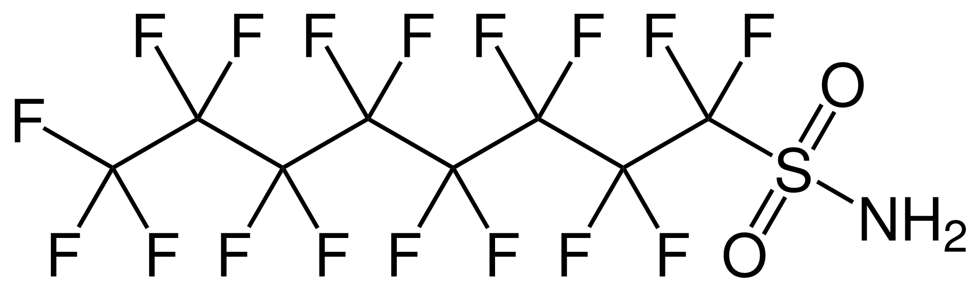 | Perfluorooctanesulfonamide  FOSA | F-(CF₂)₈-SO₂-NH₂  C₈F₁₇-SO₂- NH₂
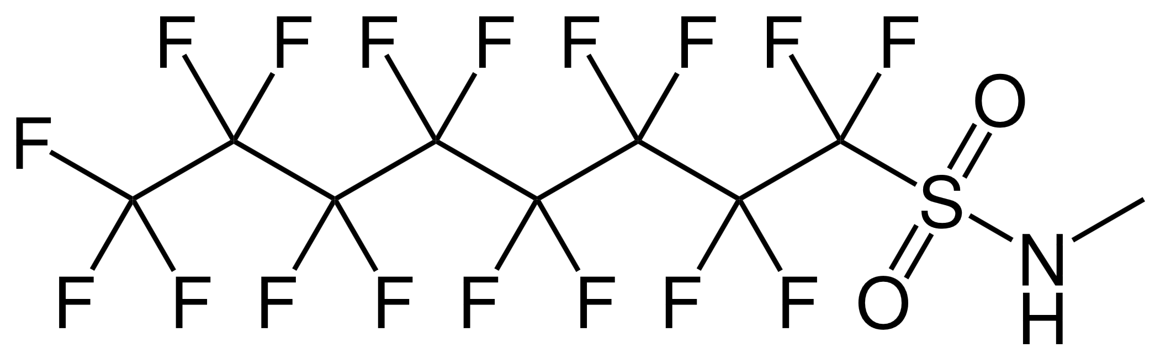 | N-methyl perfluorooctanesulfonamide  MeFOSA | F-(CF₂)₈-SO₂-NH-CH₃  C₈F₁₇-SO₂-NHCH₃
 | N-ethylperfluorooctanesulfon-amide  EtFOSA  Also: sulfluramid | F-(CF₂)₈-SO₂-NH-CH₂CH₃  C₈F₁₇-SO₂- N(H)C₂H₅
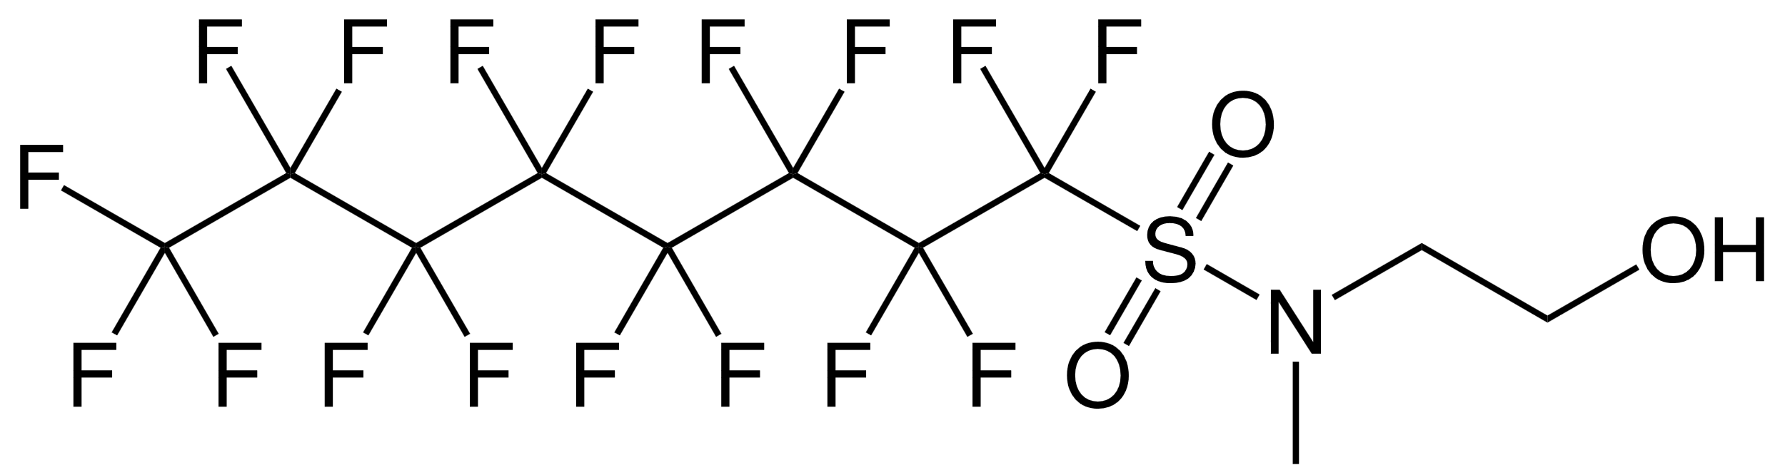 | N-methyl perfluorooctancesulfonamido ethanol  MeFOSE | F-(CF₂)₈-SO₂-N(CH₃)(CH₂CH₂)OH  C₈F₁₇-SO₂-N(CH₃)(C₂H₄)-OH
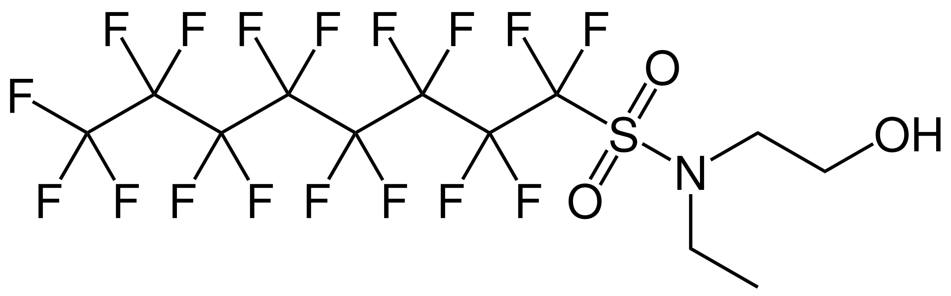 | N-ethyl perfluorooctanesulfonamido ethanol  EtFOSE | F-(CF₂)₈-SO₂-N(C₂H₅)(CH₂CH₂)OH  C₈F₁₇-SO₂- N(C₂H₅)C₂H₄-OH

____________________

Decisions BC-10/9, BC-11/3, BC-12/5, BC-14/4 and BC-15/XX of the Conference of the Parties to the Basel Convention on the Control of Transboundary Movements of Hazardous Wastes and Their Disposal; decisions OEWG-8/5, OEWG-9/3 and OEWG-12/XX of the Open-ended Working Group of the Basel Convention; and decisions SC-4/17, SC-5/9 and SC-6/11 of the Conference of the Parties to the Stockholm Convention on Persistent Organic Pollutants.
Decision SC-4/17 of the Conference of the Parties to the Stockholm Convention on Persistent Organic Pollutants
Decision SC-9/4 of the Conference of the Parties to the Stockholm Convention on Persistent Organic Pollutants
Decision SC-9/12 of the Conference of the Parties to the Stockholm Convention on Persistent Organic Pollutants
Perfluorooctane sulfonate (PFOS) as an anion does not have a specific CAS number. The parent sulfonic acid has a recognized CAS number (CAS no: 1763-23-1). For the purpose of these guidelines, PFOS is used to describe the parent sulfonic acid as listed under the Stockholm Convention.
Dubocq F., T Wang, LW.Y. Yeung, V Sjöberg, and A. Kärrman, 2020. Characterization of the Chemical Contents of Fluorinated and Fluorine-Free Firefighting Foams Using a Novel Workflow Combining Nontarget Screening and Total Fluorine Analysis. Environ. Technol. 54, 245−254
NORDEN (2017): Analysis of PFASs and TOF in products. Nordic Council of Ministers. TemaNord 2017:543
NORDEN (2015). Analysis of per- and polyfluorinated substances in articles. http://dx.doi.org/10.6027/NA2015-911
https://www.canada.ca/en/environment-climate-change/services/canadian-environmental-protection-act-registry/proposed-amendments-certain-toxic-substances-2018-consultation/chapter-6.html accessed 2020-03-26
“Outdated” means unused within the period recommended by the manufacturer.
^{, 5, 6} Refer to Annex IX to the Basel Convention for a full description of this entry.
In these guidelines, national legislation and control measures include sub-national and other applicable forms of governance.

