The Sustainable Product Initiative (SPI): Proposal for Ecodesign for Sustainable Products Regulation (ESPR) proposal, Communication & Eco-Design Working Plan 2022-2024

Background
The new Eco-Design for Sustainable Products Regulation (ESPR) proposal presented on 30 March replaces the Eco-Design Directive as the new EU’s product framework.

Political ambition:
• Setting a framework with harmonized requirements to make all products sustainable in the EU (with a few exceptions)
• Circularity as a means to achieve strategic autonomy in the EU and reduce primary raw materials dependence from other regions (incl. Russia)

Together with the ESPR, the EU Commission has adopted two relevant initiatives closely linked to the ESPR and the current Eco-Design Directive:

• The Communication on making sustainable products the norm
• The Eco-design and Energy Labelling Working Plan 2022-2024

Key aspects:
- Scope extension beyond energy-related products - almost all products impacted
- Establishes eco-design requirements for product groups beyond energy efficiency
- Increased focus on product information (e.g. Digital product Passport; labels)
- Measures to prevent destruction of unsold consumer goods
- Incentivising best performing products, incl. through mandatory public procurement

ESPR proposal: Building on the Eco-design framework
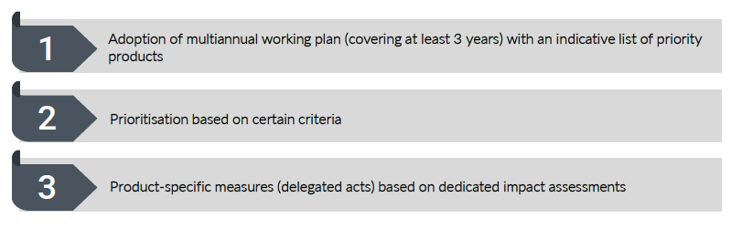

Hot topics of the initiative

Tailored approach per product group

What is it?
• Eco-design requirements to be set via delegated measures specific to individual product categories. For each specific product group, the Commission will consider the most appropriate eco-design requirements.
• However, the ESPR also provides the possibility to adopt “horizontal eco-design requirements” for a group of products with same characteristics (e.g. electronic devices), also via delegated acts
How would it work?
Identification of the eco-design requirements (performance and information requirements) will be based on different methods or standards (e.g. PEF, MEErP)
Bans?
There are no prohibitions of specific products (e.g single-use). However, current provisions are just a proposal, negotiations with Parliament and Member States (especially the EP) may change things!

Labelling & Digital Product Passport

What is it?
• Delegated acts will also establish information requirements including classes of performance (best-in-class vs worst-performing products) of a specific product group to be displayed in the form of:
• A new sustainability label (e.g. repair score, durability index, recycled content) similar to existing energy label. If appropriate, energy label will be expanded.
• European Digital Product Passport (EU DPP) – complements labels offering digital traceability along the value chain

How will the EU DPP work in principle?
• The information to be included in the product passport and the access rules will be carefully examined on a case-by-case basis (e.g who has access to what)
• Data carrier likely to be a watermark or a quick response (QR) code.
• EU registry storing information included on the product passports. The aim in principle is to simplify compliance for companies: easy bridges with recent EU databases (e.g. SCIP)

ESPR prioritisation and scope

What scope is the Commission proposing?
• All product groups are potentially within scope - except food, feed and medicines
• A preliminary assessment by the Commission has identified first ESPR targets: consumer electronics, textiles, furniture, mattresses, tyres, detergents, paints, lubricants, as well as intermediate products like iron, steel and aluminium.
• Public consultation on the categories of products to be selected for first ESPR targets expected by the end of 2022 (to be ready by 2024)

How products will be prioritized?
• Potential contribution to EU objectives
• Potential improvement of products aspects
• Volume of sales and trade
• Distribution of environmental impacts, energy and waste generation
• Need to regularly review and adapt provisions in light of technological and market developments

Defining circularity requirements

What is it?
Each delegated act will make use of methods, rules and standards to assess the priority products in order to decide on specific eco-design requirements
How will it work?
1. The LCA with the PEF method
2. Complementary assessments on environmental and circularity aspects not covered by PEF, on social aspects;
3. The economic assessment including with a Life Cycle Cost method
Some limitations
• Energy efficiency and other parameters already covered by current methodologies (Methodology for Ecodesign for Energy related Products (MEErP)
• For circularity aspects, there are general standards for reusability, upgradability, recyclability, but they will need to be reinforced/developed further on a product-by-product basis.
How?
Possibly through the support from EU’s Joint Research Centre (JRC) and in close consultation with stakeholders

The role and target on Substances of Concern (SoC)

What is it?
The ESPR proposal intends to enshrine for the first time the term “Substances of Concern” in EU legislation with the aim of tracking them and potentially restricting those substances that hinder circularity
Definition for SoC
• Defined as a Substance of Very High Concern according to REACH Regulation;
• Classified in Part 3 of Annex VI to CLP Regulation in defined hazard classes or hazard categories (e.g. carcinogenicity categories, reproductive toxicity, respiratory sensitization, etc.)
• Negatively affects the re-use and recycling of materials in the product in which it is present (not defined anywhere)
Potential measures
• Information & tracing: Obligation for manufacturers to ensure SoC traceability
• Restrictions: Restriction of the use of certain substances in specific products (bans or concentration limits) if they hinder circularity (e.g. recyclability, high-quality recycling, upgradability, durability, reparability).

Policy coherence with product-specific and horizontal legislation

Overlaps or synergies?
The ESPR proposal aims to be coherent with other EU Green Deal initiatives:
• Creating new EU product-specific rules covering products whose sustainability aspects are currently unaddressed (e.g. textiles, furniture)
• Complementing existing product-specific EU rules, by taking targeted and a tailored action to specific product/product value chain covered by general rules (Empowering Consumers, PPWD, SCGI, CPR)
• New EU rules under the current Eco-design Directive including more circularity aspects for energy-related products in the new Eco-Design Working Plan 2022-2024 (e.g. consumer electronics)
How to make sense of it?
• The EU Commission published a Communication setting the framework in policy terms and explaining possible links with other initiatives.
• The Impact Assessment of the ESPR also provides clarity on how the ESPR interacts with existing and upcoming initiatives (REACH, CPR, WFD, RoHS)
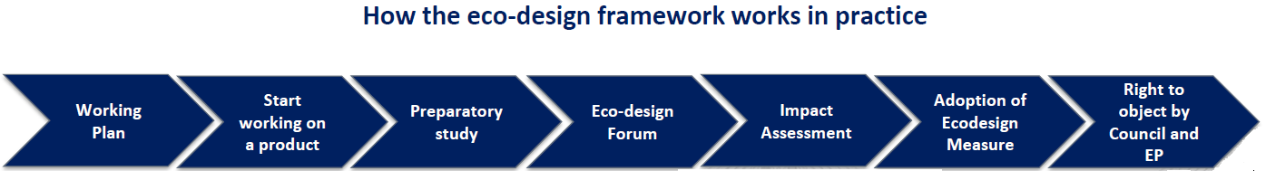

Questionnaire
Product | (e.g., tyres)
Waste stream | (e.g., tyre-derived rubber granulate/powder, recovered carbon black …)
How and what precise eco-design requirements could have an impact on the following aspect? | Extending product life cycle
 | Reducing carbon and environmental footprints of products throughout their life cycle
 | Ensuring products are fit for a climate neutral and circular economy
 | Preventing waste and boosting material recovery
 | Minimum uptake of recycled materials (how much?)
How can eco-design of the product contribute to the EU objectives of circularity and sustainability in the short-term/long-term?

What are the potential improvement aspects?

What are the volumes of sales and trade in EU/your Member State?

How much waste is generated?

What are the environmental impacts associated to mismanagement of the product once is a waste?

What have been the latest innovation in state-of-the art recycling and technologies allowing to introduce that material back into new production cycles?

How can circularity by using recycled materials help to alleviate raw material dependance from other regions?

Which product information should be available for consumers?

How could mandatory public procurement play a role?

Which method/standard would you recommend to reflect eco-design? Are already any in place (e.g., sustainability label)?

Should any substance be banned?

Which product information as recycler would you like to find reflected on the Digital Product Passport (DPP)?

How can information in the DPP help better collection, sorting and recycling?

Could the information in the DPP simplify compliance of the recovered material?

Which topics could the Joint Research Centre (JRC) address in terms of circularity of the product (e.g., recycled content, recyclability …)?

Which substances of concern (SoC) -find definition above in the text- could be diminished or removed from the product to prevent a negative impact in recycling?

In case it cannot be eliminated, how can information & tracing obligations for manufacturers be implemented to ensure SoC traceability?

Any other considerations?

