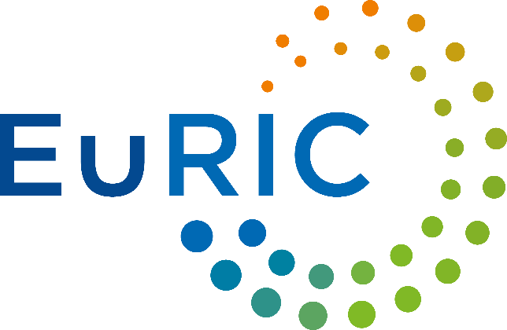
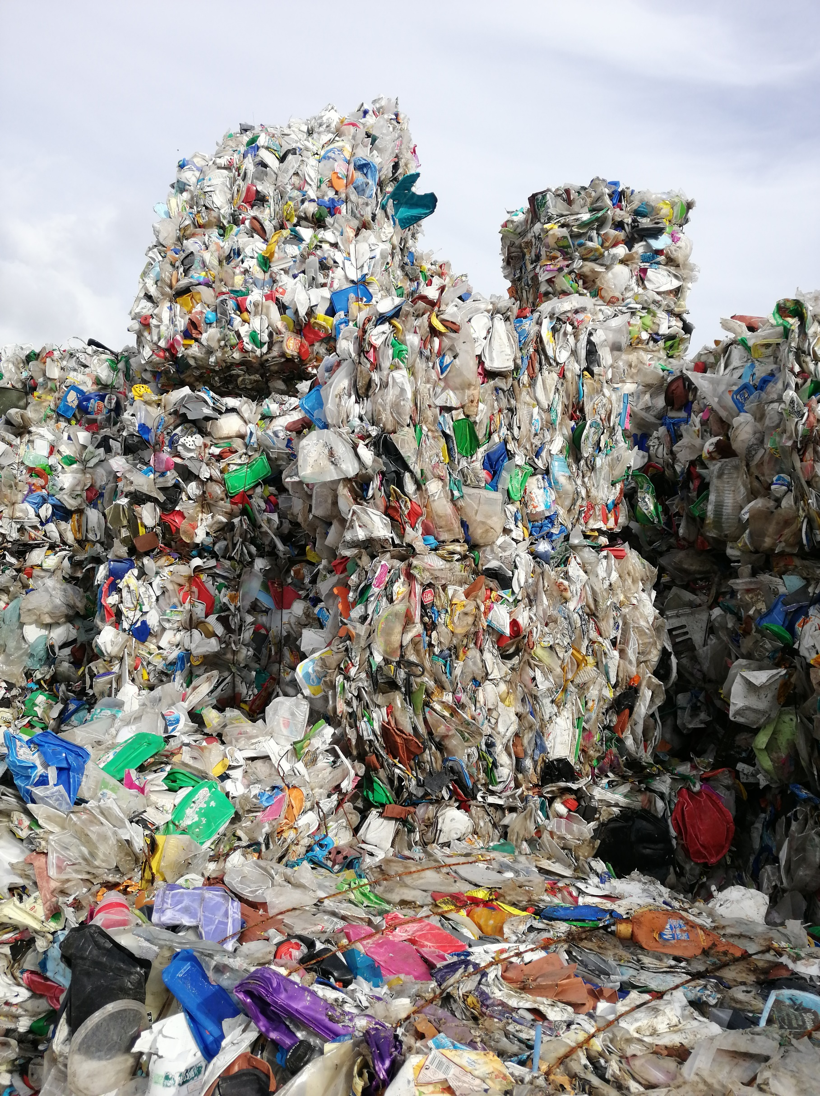
Legislative drivers for the circularity of packaging

A review on the measures for the revision of the Packaging and Packaging Waste Directive

------------------------------------

EuRIC POSITION PAPER

OCTOBER 2022

  - KEY MEASURES TO IMPROVE THE CIRCULARITY OF PACKAGING THROUGH A NEW & REVISED PPWD
EURIC POSITION PAPER
  - 28 September 2022

Introduction
The European Recycling Industries’ Confederation (EuRIC) thanks the European Commission for the informative workshops and meetings on the assessed measures within the Impact Assessment for the revision of the Packaging and Packaging Waste Directive (PPWD)

EuRIC strongly supports the need for ambitious measures to overcome barriers to packaging circularity and to ensure that “all packaging on the EU market is reusable or recyclable in an economically viable way by 2030”, as promised in the new Circular Economy Action Plan (CEAP).

Moreover, EuRIC supports the measures to increase the level of uptake of recycled content. The targets for the recycled content of PET bottles set under the SUP Directive have proven to be the only manner to de-correlate recycled PET prices from oil-based ones and thus to drive investments in capacity-building along the recycling value chain. Binding measures to incentivise circular materials’ use are thus key drivers to strengthen recycling markets and ensure the much-needed drive towards the circular economy. Thus, a continued and consistent focus is required on this level of ambition to avoid the watering down of pro-Circular measures.

EuRIC represents the recycling industry at a European level. Gathering the vast majority of national recycling federations from EU/EEA Member States, the Confederation represents about 5.500+ recycling companies – from market leaders to SMEs – generating an aggregated annual turnover of about 95 billion € by treating various waste streams such as household or industrial & commercial waste including ferrous and non-ferrous metals, end-of-life vehicles (ELVs), electronic waste (WEEE), packaging (paper and plastics), end-of-life tyres or textiles

In this paper, the key positions of EuRIC on the assessed measures for the revised PPWD are outlined, with observations and recommendations for the sake of circularity of packaging. EuRIC looks forward to working closely with the European Commission to ensure the introduction of harmonized rules on packaging that reflect better the principles of circular economy.

EuRIC’s position in a nutshell
- Strong support to a recyclability threshold and reinforcement of the essential requirements.
- Call for strong measures on compulsory design for recycling of packaging, with in-real-life assessment
- Opposition to the introduction of the “right of first refusal”
- Strong support to the ambitious version of proposed RC targets for plastic packaging.
- Opposition to a joint bio-based / recycled content target
- Opposition to an exemption on RC and recyclability targets for reusable packaging
- Strong support to the change of the legal format from Directive to a Regulation

Contents
Introduction 1
Key measures | EuRIC’s position in a nutshell 1
All packaging must be recyclable by 2030 3
Definition of recyclable packaging 3
Assessment and certification of recyclability of all packaging items 5
Design for recycling guidelines and the negative list 6
Eco-modulation of EPR fees 6
Deposit Return Systems (DRS) 7
Priority access 8
Recycled Content targets 8
Calculation and reporting of recycled content 9
Biodegradable and compostable plastics 9
Reusable Packaging – not an exemption 10
Legal Instrument 10

All packaging must be recyclable by 2030

Definition of recyclable packaging
Recyclability is one of the key requirements to facilitate the drive towards circularity in the packaging and packaging waste sector. Therefore, EuRIC supports a strong quantitative definition of recyclable packaging to ensure real recyclability is realized in packaging placed on the market.

 | Recyclable packaging is that which can be effectively and efficiently separated from the waste stream, collected, sorted and aggregated into defined streams for recycling processes, and recycled at scale through relevant industrial processes such that it is turned into a secondary raw material, in line with Article 6a of the PPWD for calculating recycling targets, and of a sufficient quality that it can find end markets to substitute for the use of primary raw material.  Innovative packaging placed on the market that requires new infrastructure to be developed shall be recycled at scale within a maximum period of two years.  At least 95% of the functional unit of packaging shall be recyclable according to this definition, with the remaining minor components compatible with the relevant recycling process and not hindering the recyclability of the main component at scale.  Eunomia’s definition

EuRIC globally supports the concepts used in the definition of recyclability proposed by Eunomia. However, for the definition to be fully operational and to avoid ambiguity, some precisions and definitions are required.

- The definition of recyclable packaging lacks an economic dimension. EuRIC proposes to add “recycled at scale in an economically viable way” as it is stated in the New Circular Economy Action Plan (“all packaging on the EU market is recyclable in an economically viable way by 2030”). Economically viable is a key parameter that is directly linked to incentives, such as eco-design and recycled content, to drive sustainable packaging that is easily recyclable when it reaches end of life stage.
- It is also necessary to include a geographical scope. If a packaging product is technically recyclable, but in a country, it is being discarded from the recycling process, it cannot be considered recyclable. EuRIC proposes to add “recycled at scale with sufficient geographical coverage in each Member State”
- Further clarification on “innovative packaging” is highly needed. Innovative packaging can be recycled either within the existing collection, sorting and recycling infrastructures or can require new infrastructures or modifications to existing infrastructures. EuRIC proposes that the recyclability of innovative packaging and their impact on collection, sorting and recycling infrastructures is assessed before placing on the market. For the innovative packaging which requires new infrastructure, EuRIC supports that the infrastructure for the recycling of this kind of packaging should be developed within a period of two years after the first placing on the market.
- The definition of “functional unit of packaging” should be included in the text. This definition should include all the elements of the functional unit of packaging (ex. lid, label, and body in a bottle).

EuRIC supports the inclusion of a recyclability threshold. However, the current wording is not precise enough to assess the feasibility of the proposed 95%.

If the recyclability threshold is to be assessed on the basis of the % of the weight that is targeted by the recycling process as an input, then 95% is achievable. The wording should be changed to “95% of the weight of the functional unit of packaging should be targeted to a recycling process”. For example, for the calculation of the recyclability of a PET bottle, the PET body and the PE cap are targeted to recycling process while the label is not and should represent less than 5% of the weight of the functional unit of packaging. In a crips packet, the PP material is targeted to a recycling process while the metallized material is not.

Considering the last point, it is not possible to achieve a high recyclability without a high collection and sorting rate. More clarification is needed on whether the % applies across the value chain. EuRIC understands that “At least 95% of the functional unit of packaging shall be recyclable” should mean that “at least 95% of the weight of the functional unit of packaging shall be collected, sorted and targeted to a recycling process as an input”.

Moreover, the definition should take into account the recycling rate of the packaging item, meaning that the obtained recycled material must be of a sufficient quality, but also quantity. Taking the example of French and Spanish legislation on packaging “recyclable packaging is that which can be recycled on an industrial scale with commercial processes that guarantee sufficient quality of the recycled material for subsequent uses, and in a quantity greater than 50% of the mass of the waste collected from that type of packaging”.

Recyclable packaging is that which can be effectively and efficiently separated from the waste stream, collected, sorted and aggregated into defined streams for recycling processes, and recycled at scale ,with sufficient geographical coverage in each Member State, through relevant industrial processes such that it is turned into a secondary raw material, in line with Article 6a of the PPWD for calculating recycling targets, and of a sufficient quality and in a quantity greater than 50% of the mass of the waste collected that it can find end markets to substitute for the use of primary raw material.

Innovative packaging placed on the market that requires new infrastructure to be developed shall be recycled at scale within a maximum period of two years.

At least 95% of the weight of the functional unit of packaging shall be recyclable according to this definition, with the remaining minor components compatible with the relevant recycling process and not hindering the recyclability of the main component at scale.

Eunomia’s definition with EuRIC’s inputs

With the aim of continuous improvement and avoiding excessive pressure to classify some packaging as 95% recyclable, EuRIC suggests introducing a recyclability scale with several thresholds rather than a black or white single threshold. Recyclability threshold could be (% are given as examples):
- Circular packaging: 95% recyclability threshold + 75% recycled content of similar origin
- Fully recyclable packaging: 95% recyclability threshold + no incompatible minor component
- Partially recyclable packaging: 70% to 95% recyclability threshold + no incompatible minor component
- Poorly recyclable packaging: <70% OR incompatible minor component

The PPWD presents an exceptional opportunity to promote high quality recycling through the reinforcement of the essential requirements. These should define that packaging may be placed on the EU market only if it is qualified as “partially recyclable packaging” or “fully recyclable packaging” by 2025. By 2030, all packaging must be qualified as “fully recyclable packaging” to be placed on the EU market.

Assessment and certification of recyclability of all packaging items
The assessment and certification of the recyclability of packaging is key to avoid misleading label and Self-certified claims. A Commission implementing decision would be useful to precise the method for measuring the recyclability threshold.

EuRIC proposed the following requirements for the assessment and certification of the recyclability of packaging:

- Consider the recyclability of all the elements of the functional unit of the packaging and the interaction between them.
- That the packaging material and component materials are effectively recycled and not only if they are potentially recyclable.
- The same assessment and certification methodology should be available for all types of packaging, following the recycling process for each typology.
- Assessing under the systems actually applied in each country.
- For packaging innovation technologies, quantification cannot be established on the basis of theoretical generalities alone. Empirical tests must be carried out to attest to this. Therefore, protocols must be established to demonstrate the recyclability of the packaging and/or its components.
- As the existing collection, sorting and recycling processes in each member state need to be taken into account for the quantification of recyclability, the result will be valid in that Member State and those Member States where it has the same characteristics.
- Take into account packaging behaviour throughout all stages, from their use/consumption until their effective reincorporation into a production process.
- Include a scale of recyclability assessment: fit for closed-loop recycling; fit for open-loop recycling; unfit for recycling
- The methodology, evaluations, reviews, quantification processes should involved the whole packaging value chain and the certification should be carried out by entities independent from the packaging makers, packer-fillers or retailers. Neutrality and rigor!
- The outcome of the quantification of recyclability should be consistent with the assessment of the recovering and recycling sectors, at least in that Member State.
- Quantification should be time-limited (no more than 3 years). Constant changes in packaging, collection, sorting, recycling and application technologies may cause results to vary significantly.
- But the characteristics of the containers should not be standardized, since the recycling process and the effect on the characteristics of the design of the containers are not the same for all.
- It should not include the measurement of contained recycled material, as these are distinct concepts that should be assessed independently.
- Registered consultants and administrations could have valuable information

Design for recycling guidelines and the negative list
Design for recycling is essential to drive packaging’ sustainability.
EuRIC is against the inclusion in the PPWD or in an implementing act of a “negative list” prohibiting packaging characteristics (materials, components or features) which impede, or hinder recycling. indeed, such a list would be very difficult to update and might thus curtail innovation instead of fostering it.

EuRIC believes that recyclability of packaging must be assessed and certified through a methodology that takes into account the technology developments and innovation in packaging production, collection, sorting and recycling in a regular basis. That is why, as mentioned before, the assessment and certification of the packaging recyclability should be time-limited (no more than 3 years).

Eco-modulation of EPR fees
It is estimated that over 80% of products’ environmental impacts are determined at design stage. Still, the vast majority of products placed on the market are designed without any consideration for their end-of-life stage.

EuRIC calls for the eco-modulation of fees to ensure that Extended Producer Responsibility (EPR) schemes bridge the design phase with the re-use and recycling stage. Thus, EuRIC supports the introduction of eco-modulated EPR fees to reward those producers that place on the market highly-recyclable packaging with recycled content.

“We recycle today
what was produced yesterday”

Moreover, EuRIC supports an eco-modulation system that introduces specific incentives (“bonuses”) for the design and production of recyclable packaging, as well as the efficient use of materials. The criteria for the ecomodulation should be developed taking into account:

- The reduction in weight or volume of packaging through eco-design, without compromising the recyclability of the packaging.
- The recyclability of packaging, once it is assessed and certified against the criteria described above and considering the % of the functional unit of packaging (including all elements) available for quality recycling. If the packaging item is labelled with this information, then a special bonus can be granted.
- The incorporation of Raw Materials from Recycling in the new packaging items. If the packaging item is labelled with the % of recycled content, then a special bonus can be granted.

Ecomodulation of EPR fees can be an important mechanism to meet the recycling and circularity targets set under the PPWD. Then, fee structures must take into consideration the minimum recycling targets for the specific materials and must be regularly assessed and updated to reflect innovation and substantial changes in the collection, sorting and recycling infrastructure.

Deposit Return Systems (DRS)
The European Commission consulted stakeholders on the possibility of introducing EU-wide mandatory Deposit Return Systems for certain beverage containers as well as the minimum requirements to be set out for all DRS.

In some Member States, Deposit Return Systems have proven to result in an increased collection rate for some materials such as aluminium cans, PET and glass bottles. This is the case of Estonia, one of the earlies adopters of PET DRS, with a PET collection rate of 86%. However, DRS is not a silver bullet. For instance, without a DRS in place, Belgium achieves high collection rates for PET bottles, with current rates at 95%. In this particular case, where plastic household packaging is collected door-to-door via the “blue bag”, the change and implementation of a new different system would cause difficulties and confusion whilst bringing little benefit. It shows that DRS are not essential to achieve high levels of recycling, and thus, EuRIC believes that the scope of DRS should be decided at Member State level on the basis of collection rate performances of each packaging categories.

Nevertheless, Deposit Return Schemes can help Member States with poor collection rates reach the collection targets set under the SUP directive or the new PPWD. In any case, DRS should be designed and governed to:
- Avoid the monopolization of the waste market and enable several operators rather than one centralized operator (with excessive pricing power), which will create an active, open and competitive marketplace.
- Guarantee the quality of collected waste for recycling processes.
- Guarantee fair access to waste auctions to all recyclers (reasonable size of auction lots, number and frequency of auctions). For example, once-a-year national "the winner takes it all" auctions should be prohibited because they could dramatically disorganize the waste supply chains of recyclers, leaving some plants without supply for long periods.
- Guarantee that recyclers can purchase the waste and retain the property of recyclates. The DRS should not be used to remove ownership of recyclates from recyclers and turn them into recycling service providers. This would lead to margins that are too low to support innovation and investments.

Consequently, if minimum requirements are to be set, they should provide for a governance of DRS were recyclers take part of the decision-making process, in particular regarding the auction process and technical specifications

Moreover, consumption habits and retail structures are highly variable between Member States to set minimum requirements to obligate return from retailers. The DRS collection points locations, and their side effects (diversion of consumers away from small retailers for instance) should be analysed and decided at MS and local levels.

The System Operators should be non-profit and funded by material revenue and producer contributions. However, unredeemed deposit should not fund the DRS operations because it is an incentive not to maximize the collection rate. Since they are paid by citizens, unredeemed deposit should fund public actions on waste prevention and reduction.

Priority access
In the past few months, some companies and associations from the beverage industry have been calling on the European Commission to introduce a “right of first refusal” or “priority access” mechanism on recycled plastic, to be incorporated in the new PPWD, through the minimum requirements of DRS or EPR, covering governance structure.

EuRIC believes that introducing the “right of first refusal” to recycled plastic material would end up with destabilizing the Single Market rules and thus, entirely jeopardizing the functioning of the market for plastic waste and recyclates.

Granting the beverage industry a “priority access” undermines basic free market principles and disregards the efforts and investments made by the waste management industry to achieve high quality packaging sorting, to improve the efficiency of the recycling process and to increase the quality of recyclates.

Recycled Content targets
Currently, there is a minimal uptake of Raw Materials from Recycling (RMR) in packaging, particularly for plastics (12%, as estimated by Eunomia). However, recycling rates of high-quality recyclates remain much higher. The explanation of this oddity lies in market prices of RMR vs. virgin material prices. The COVID crisis (the collapse of oil prices, and subsequent virgin polymer prices; with the unwavering price of RMR) has proven that without Recycled Content targets linear value changes always have the economic edge.

Recycled content is the most efficient tool to reward recycling environmental benefits to pull the demand for recycled materials in new products and level the playing field with primary materials. This measure will not only increase the recyclates consumed in Europe, but will also drive-up the demand for our high-quality recyclates (therefore increasing recycling rates).

EuRIC strongly supports the Ambitious Plastics Recycled Content Targets proposed by Eunomia, with a technology neutral approach. These targets will be achieved thanks to the push on investments in R&D through a mandatory demand that secures the investments to improve the recycling capacity.

When tracking the recycled content targets, if pre-consumer is to be counted for the proposed targets, this should be at baseline. If not possible, monitoring is crucial, separating % of pre-consumer from % of postconsumer. Whereas % of pre-consumer should decrease with time (i.e., it reflects inefficiency of an industrial process), % of post-consumer should increase (i.e., it reflects EU moving to a circular economy for plastics). By no means, should scrap be included in pre-consumer

Beyond plastics, recycled content targets should further be established in other material categories. EuRIC supports recycled content targets for plastics, paper, textile, aluminium, steel, and glass packaging. Though some producers already claim to achieve high recycled content (i.e., for aluminium and glass), a target matching current practices would ensure that laggards are not able avoid their responsibility to ensure circularity.

Calculation and reporting of recycled content
A strong methodology of any Recycled Content targets or reporting obligations are crucial to avoid possible green-washing opportunities. EuRIC supports real-life criteria which ensure recycled content is measured at a product level. This can stop producers claiming recycled content on packaging, which in reality poses no Recycled Content. Facility and product-level methodologies will ensure that the recycling incentivised by targets is ensured harmoniously across all EU-27 Member States, rather than creating a fractured market.

EuRIC strongly supports a segregation or controlled blending chain of custody model as method for the calculation and verification of recycled content, where the physical separation of material ensures that recycled content is physically present in the final product. If a mass balance model is admissible when the physical separation is not possible, this should be always measured at batch or facility-level, knowing the proportion of recycled material fed into the process/facility and calculating the recycled content in the output.

Biodegradable and compostable plastics
As stressed at length in EuRIC’s position on the impacts of the biodegradable plastics on circularity, EuRIC further does not see any current justification or added value in the focus on compostable packaging, in regard to achieving Circular Economy objectives.

Despite the fact that biodegradable plastics (BDPs) can theoretically shorten the life cycle of plastics, due to lack of infrastructure and a misconception by the consumer about what biodegradability means, most of BDPs are not properly disposed at their end-of-life (EoL) and they are mixed with traditional plastics. This creates a negative impact on the efficiency of conventional plastic sorting systems across EU and jeopardizes recyclates quality because BDPs - contrary to bio-based plastics - do not fit in the sorting and recycling infrastructure. This means that if BDPs end up in the same waste stream as conventional plastics, they will act as contaminants and the quality of recyclates will be lower.

Even when BDPs are properly disposed at their EoL, problems may rise during composting, which is the reason BDPs, even EN 13432 certified BDPs, are not allowed in the bio-waste of many Member States. As a consequence, BDPs from packaging are removed from the bio-waste and incinerated at waste to energy plants.

This shows that biodegradable plastics are not a silver bullet to the plastic waste problem but just as another waste to be properly managed. For the correct functioning of the circular economy, it is EuRIC’s recommendation that all plastic products must be designed according to the design-for-recycling principles, which means that the collection, sorting and recycling of the material must be possible within the existing infrastructure and this needs to be determined by extended producer responsibility (EPR) schemes.

Under the current scenario, there is a need for clarification about biodegradability and composability as well as the update of EN 13432 standard. It is of utmost importance to set strict criteria for the use of biodegradable plastics in order to restrict the types of plastics that can be discarded in the bio-waste.

It is important to make an exhaustive list of applications where compostable plastics may be used in combination with the quality mark “compostable”, once it is assessed that they provide environmental benefits, and they are certified against an improved EN 13432 standard.

Reusable Packaging – not an exemption
The promotion of reusable packaging options is supported by the European recycling industry. As is clear from the Waste Framework Directive, reusability is higher up the waste hierarchy than recycling. Nevertheless, the promotion of reusability should not push the problems faced today further down the road (i.e., non-recyclable reusable packaging after “x” loops being treated via low disposal / recovery options).

Even with a high number of cycles within is lifetime, recycling should remain the minimum benchmark for reusable packaging, to lead to the lowest emissions possible over the life-cycle of the packaging, however further to not disturb the currently functioning recycling systems in place. Therefore, the promotion of reusable packaging should be coupled with the packaging’s recyclability and incorporation of recycled content, ensuring that all reusable packaging is further recyclable and that recycled contents are met by this kind of packaging as well – not being considered as an exemption.

Moreover, before setting reuse targets for packaging, life cycle assessments must take place to ensure that they can demonstrate clear benefits for the environment and society. The incorporation of reusable packaging items on the market needs the development of cleaning infrastructure, which
requires large quantities of water and energy. In addition, more energy and material are needed to produce reusable packaging, since it is designed to be stronger than a single-use alternative so it can be used over and over again.

Recent reports and studies have shown that reusable solutions are not always the most environmental-friendly ones: for example, the carbon footprint of single-use cardboard boxes outperforms reusable plastic boxes when moving tomatoes internationally .

Consumers attitude is also an important point. If consumers buy a reusable packaging item but they toss it in the garbage instead of refilling it, the environmental footprint of that would exceed a SUP item. Unfortunately, there is no information on how often consumers actually refill reusable packages.

EuRIC recommends that, if reusable targets are to be defined, they should be set for very specific items and purposes once life-cycle assessments have been conducted and proved the environmental benefits.

Legal Instrument
EuRIC supports the change of the legal format from Directive to a Regulation in order to ensure a harmonized implementation and enforcement of the new rules, which are essential to preserve a smooth functioning of the internal market as well as high level of circularity of packaging products placed across the EU.

Décret n° 2022-748 du 29 avril 2022 relatif à l'information du consommateur sur les qualités et caractéristiques environnementales des produits générateurs de déchets
Spanish Royal Decree on Packaging and Packaging Waste
FostPlus Source: https://assets.foleon.com/eu-west-2/uploads-7e3kk3/252/220215_fost_plus_materiaalfiche_en.0c8f7bee38da.pdf
https://ec.europa.eu/environment/integration/research/newsalert/pdf/569na1_en-1313_lca-of-agricultural-tomato-packaging-boxes-for-climate-impact_v2.pdf

