05 December 2022

Subject: POP Annex I – comments on the proposal to update the UTC for PBDEs

The undersigned associations would like to provide comments on the European Commission (EC) proposal presented during the last POP Expert group on November 24th.
This document focuses on the environmentally sound management of plastics containing PBDEs.

We understand the necessity to progressively phase out persistent organic pollutants (POPs) as a key enabler to transition towards a toxic-free circular economy for plastics. The gradual phasing out of POPs present in products being placed on the market will translate into cleaner recycling cycles for plastics waste, thereby benefitting the plastics recycling industry as more waste can be recycled into new products.
The plastics recycling industry has made vast progress to treat complex waste streams. The processes implemented at the recycler facilities successfully manage to produce recyclates below 500 mg/kg of the sum of the PBDEs. The remaining fraction, containing the concentrate of PBDEs, is to be sent to disposal for destruction (see Annex I of this document).
Considering how plastic waste containing PBDEs is treated in a recycling facility, we strongly believe that mechanical recycling is the best route to ensure that these plastics are sorted and destroyed accordingly. Consequently, the limits set in the POPs Regulation should facilitate mechanical recycling as a solution for the management of plastics containing PBDEs, in line with the transition to a circular economy.
With regard to the EC proposal shared during the last POP Expert group, lowering the UTC limit in Annex I to 350 mg/kg will lead to a situation where waste which can currently be recycled will instead be sent to disposal, thereby contradicting the waste hierarchy and the principles of a circular economy. In fact, such a low limit in Annex I would be premature, considering the technical limitations of recycling technologies processing waste containing PBDEs currently available in all EU Member States (MS). Lowering the limit too quickly will result in exports of “second-hand” products outside the EU which will consequently lead to uncontrolled recycling of these materials. As demonstrated by various studies, these recycled materials containing POPs will be converted into products and imported into the EU.

To ease the enforcement and implementation of the Regulation, a similar timeline as adopted in the agreement for Annex IV should be followed, with a limit of 500 mg/kg for a minimum of 3 years (see Annex II of this document).
We therefore stress the need for an alignment between the limits set in Annexes I and IV to the POPs regulation.
The Annex IV provides for a gradual reduction of the threshold in 3 and 5 years after entry into force. If applied to Annex I, this timeline would both address the phase out of the PBDEs whilst ensuring the continuity of the recycling activities.
Overall, we call for the maintaining of the UTC limit at 500 mg/kg for three years, following the agreement established in the POPs Regulation Annex IV.
The undersigned associations remain available to further discuss the elements tackled in this document with the relevant team.

About Plastics Recyclers Europe
Plastics Recyclers Europe (PRE) is an organization representing the voice of the European plastics recyclers who reprocess plastic waste into high-quality material destined for the production of new articles. Recyclers are important facilitators of the circularity of plastics and the transition towards the circular economy.
Plastics recycling in Europe is a rapidly growing sector representing over €7.7 billion in turnover, 9.6 million tonnes of installed recycling capacity, more than 650 recycling facilities and over 20.000 employees.
www.plasticsrecyclers.eu
OTHER ASSOCIATIONS TO ADD BOILERPLATES
About European Electronics Recyclers Association

About European Recycling Industries Confederation

About FEAD: European Waste Management Association

Annex I: Mechanical recycling of Waste Electronic and Electrical Equipment (WEEE)/End-of-Life Vehicles (ELV) plastics

In the past, PBDEs have been added to plastics to prevent or slow down the ignition process. Due to safety standards, flame retardants are mostly used in electronic and electrical equipments and in vehicles. While the ban of PBDEs in the EU under the POPs Regulation prevents the introduction of new PBDEs into plastics material cycles, plastics containing PBDEs are still present in the waste stream due to the long life-service of the article (Figure 1).
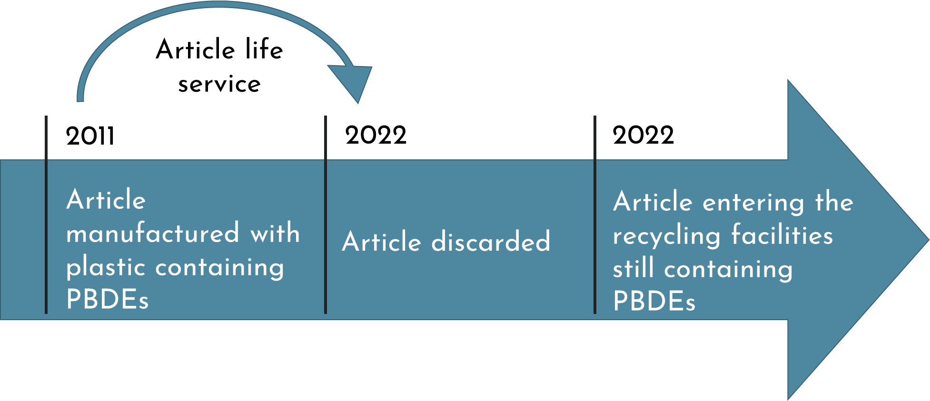
Figure 1: Exemplary timeline - from article manufacture to recycling in the field of EEE

To ensure the safety of the recycled materials and reduce the contamination of the recycling cycles, WEEE and ELV recyclers have developed innovative processes to separate plastics containing PBDEs from the main waste stream, namely the sink/float technology (Figure 2).

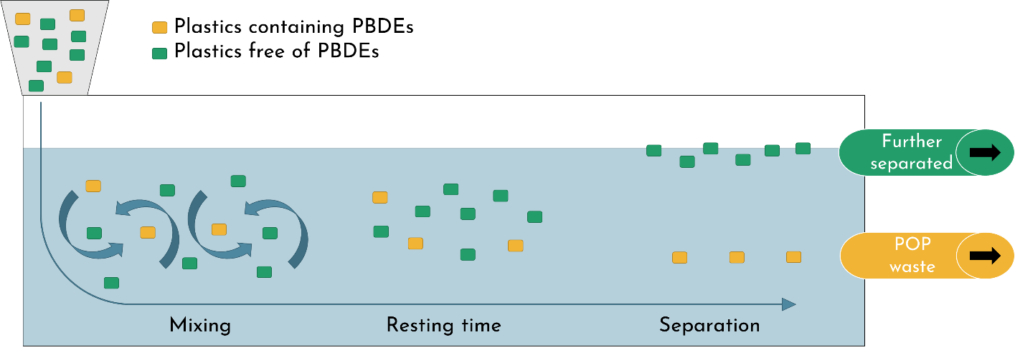
Figure 2: Sink/float technology
This technology separates plastics based on the intrinsic density of the polymer type. A bath with a set density at 1.1g/cm³ separates the plastics with a density above 1.1g/cm³ (sink fraction – yellow flakes on the scheme) and below 1.1g/cm³ (float fraction – green flakes on the scheme).

The addition of PBDEs to a polymer increases the material density, which makes it a property to exploit for the clustering of plastic containing PBDEs. Consequently, the sink fraction (>1.1g/cm³) concentrates the plastics containing PBDEs (density above 1.1g/cm³) while the float fraction contains conventional plastics (e.g., polyolefins and styrenics).
In the example below, the incoming material from WEEE/ELV exhibits an average concentration of 5,000 mg/kg PBDEs. Owing to the sink/float process, the PBDEs are concentrated in a waste fraction with a PBDEs concentration above 9,500 mg/kg, which is to be sent for destruction in an environmentally sound manner (as explicitly prescribed in Annex IV). The remaining fraction has a PBDEs concentration below the current Annex I limit (e.g. 500 mg/kg) (Figure 3).
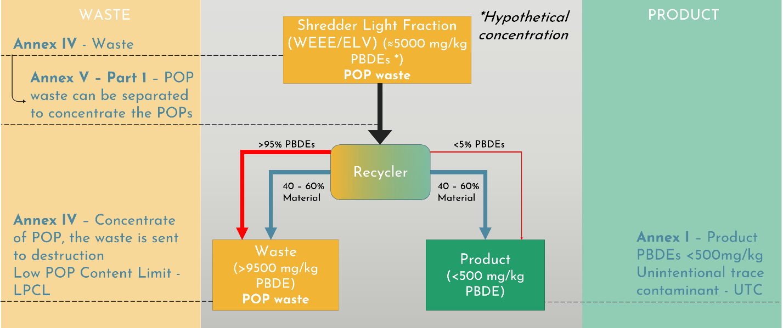
Figure 3: Separation of plastics containing PBDEs at a WEEE/ELV recycler

Annex II: Agreement POPs Regulation Annex IV

On October 24th, the proposal for a Regulation to the European parliament and the Council amending Annexes IV and V to Regulation (EU) 2019/1021 on POPs has been formally adopted by the Council. Annex IV of the POPs Regulation sets requirements on waste, by which a waste containing POP substances above their regulatory limits needs to be destroyed. The following thresholds apply for the sum of the PBDEs.
The agreement foresees a three-step approach:
- Previous limit: 1000mg/kg
- Step 1: after entry into force, the limit is set at 500 mg/kg;
- Step 2: an automatic reduction to 350 mg/kg, 3 years after the entry into force or the value set in Annex I if higher;
- Step 3: another automatic reduction to 200 mg/kg, 5 years after the entry into force or the value set in Annex I if higher.

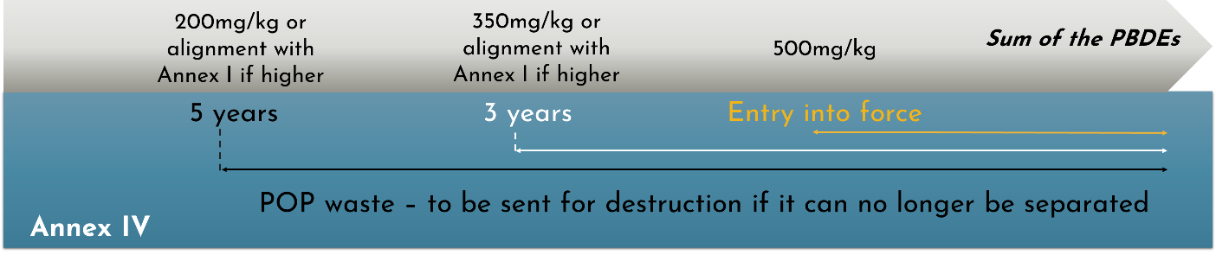
Figure 4: Provisional agreement on the Annex IV limit for the PBDEs

